

Requirement & Design Specification

Recruitment Management System (RMS)
Version: 1.0

– DaNang, August 2022 –

Record of Changes
Version | Date | A*  M, D | In charge | Change Description
V1.0 | 15/2 | A
*A - Added M - Modified D - Deleted

Contents
Record of Changes 2
I. Overview 7
1. User Requirements 7
1.1 Actors 7
1.2 Use Cases 8
2. Overall Functionalities 11
2.1 Screens Flow 11
Actor Admin 11
Actor Department Head 12
Actor HR Manager 13
Actor Candidate 14
2.2 Screen Descriptions 15
2.3 Screen Authorization 17
2.4 Non-UI Functions 19
3. System High Level Design 20
3.1 Database Design 20
3.2 Code Packages 23
II. Requirement Specifications 26
1. Auth 26
1.1 UC-01_Register Account 26
1.2 UC-02_Verify Registration Email / Resend OTP 28
1.3 UC-03_Login 29
1.4 UC-04_Login/Register with Supabase or Google Session 30
1.5 UC-05_Refresh Session 31
1.6 UC-06_Logout 33
1.7 UC-07_Reset Password 34
2. Identity 36
2.1 UC-10_Manage Users and Roles 36
2.2 UC-11_Check User Email Availability 37
2.3 UC-12_Manage Organizations 38
2.4UC-13_Manage Organization Settings 39
2.6 UC-14_Manage Departments 40
2.5 UC-15_Manage Department Team Members 41
3. Identity / Calendar 43
3.1 UC-09_Connect Google Calendar and Create Meet Link 43
4. Recruiting 44
4.1 UC-16_Create Recruitment Request 44
4.2 UC-17_Update Recruitment Request 45
4.3 UC-18_Submit Recruitment Request 46
4.4 UC-19_Assign Recruitment Request to HR 47
4.5 UC-20_Return Recruitment Request for Revision 49
4.6 UC-21_Request Changes from HR 50
4.7 UC-22_Forward Recruitment Request to Admin 51
4.8 UC-23_Make Recruitment Request Decision 52
4.9 UC-32_Manage Roles / Job Descriptions 53
5. Recruiting / Audit 54
5.1 UC-24_Track Recruitment Request and Audit Logs 54
6. Planning 56
6.1 UC-25_Create Overall Plan 56
6.2 UC-26_Submit / Resubmit Overall Plan 57
6.3 UC-27_Approve / Reject Overall Plan 58
6.4 UC-28_Start Campaign 59
7. Task Planning 60
7.1 UC-29_Create and Update Task Plan 60
7.2 UC-30_Assign HR Task 61
7.3 UC-31_Update Task Status 63
8. Job Posting 64
8.1 UC-33_Manage Job Postings and Media 64
8.2 UC-34_Browse Public Job Postings 65
9. Applications 66
9.1 UC-35_Manage Applications 66
9.2 UC-36_Manage Invites 67
10. Evaluations 68
10.1 UC-37_Trigger and View Evaluations 69
11. Profiles 70
11.1 UC-38_Manage Candidate Profile and Avatar 70
12. CV 71
12.1 UC-39_Upload and Manage Candidate CV 71
12.2 UC-40_View Latest Candidate CV 72
13. CV / AI 73
13.1 UC-41_Parse CV and Generate Embeddings 74
13.2 UC-42_Search and Screen CV 75
14. Talent Search 76
14.1 UC-43_Search Talent and Record Search Feedback 76
14.2 UC-44_Expand Talent Query / Export Feedback Triplets 77
15. Profiles / Evidence 78
15.1 UC-45_Upload and View Documents / Evidence 78
16. Interview 80
16.1 UC-46_Schedule Interview 80
16.2 UC-47_Candidate Confirm / Request Reschedule / Cancel Interview 81
16.3 UC-48_Reschedule or Cancel Interview 82
16.4 UC-50_View Completed Interviews and Interview Details 83
17. Interview / Notification 84
17.1 UC-49_Send Interview Invitations and View Email Logs 85
18. Interview Results 86
18.1 UC-51_Submit Interview Panel Feedback 86
18.2 UC-52_Record Interview Result and Final Recommendation 87
18.3 UC-53_Admin Review Interview Results 88
19. Hiring Decision 89
19.1 UC-54_Make Final Hiring Decision / Request More Information 89
20. Offers 91
20.1 UC-55_Generate, View and Send Offer Letter 91
20.2 UC-56_Respond to Offer 92
21. Notifications 93
21.1 UC-57_Manage Notifications 93
22. Dashboard 94
22.1 UC-58_View Dashboards 94
23. Reports 96
23.1 UC-59_View Reports and Export Annual Report 96
24. Security 97
24.1 UC-60_Access Protected Route / API 97
25. Health 98
25.1 UC-61_Monitor System Health 98
26. Supplementary Functional Description Templates 99
26.2 RS-02_Google Calendar Authorization and Meet Scheduling 101
26.3 RS-03_Department-Scoped Recruitment Requirement and Approval Workflow 102
26.4 RS-04_Task Deadline Reminder and Idempotent Delivery 103
26.5 RS-05_Interview Panel Evidence, Feedback, and Final Recommendation 105
26.6 RS-06_Final Hiring Decision and Offer Acceptance Completion 106
26.7 RS-07_Public Job Posting Media and Candidate Visibility 107
III. Design Specifications 109
1. Recruitment Management System (RMS) 109
1.1 System Access and Authentication 109
1.2 Recruitment Request Management 112
1.3 HR Recruitment Operations 115
1.4 Interview and Hiring Decision 119
1.5 Administration, Reporting and Candidate Self-service 122
IV. Appendix 125
1. Assumptions & Dependencies 125
2. Limitations & Exclusions 125
3. Business Rules 125

I. Overview

1. User Requirements

1.1 Actors

# | Actor | Description
1 | Admin | Manages the entire system configuration, security settings, and master data. Responsible for user account creation, role-based access control (RBAC), department management, system activity monitoring, and system-wide audit logging.
2 | Department Head | Initiates and submits recruitment requests for their department. Reviews and approves hiring requisitions, evaluates candidate interview performances, and makes the final hiring decisions for their respective team.
3 | HR Leader | Oversees the entire recruitment process. Reviews and approves recruitment campaigns, allocates workloads to HR staff, approves salary proposals/offers, and monitors the overall efficiency and metrics of the hiring pipeline.
4 | Candidate | The external user applying for jobs. Searches for open positions, submits profiles and resumes (CVs), tracks application status, schedules or confirms interview slots, completes pre-employment assessments, and communicates with the recruitment team.

1.2 Use Cases

a. Diagram(s)
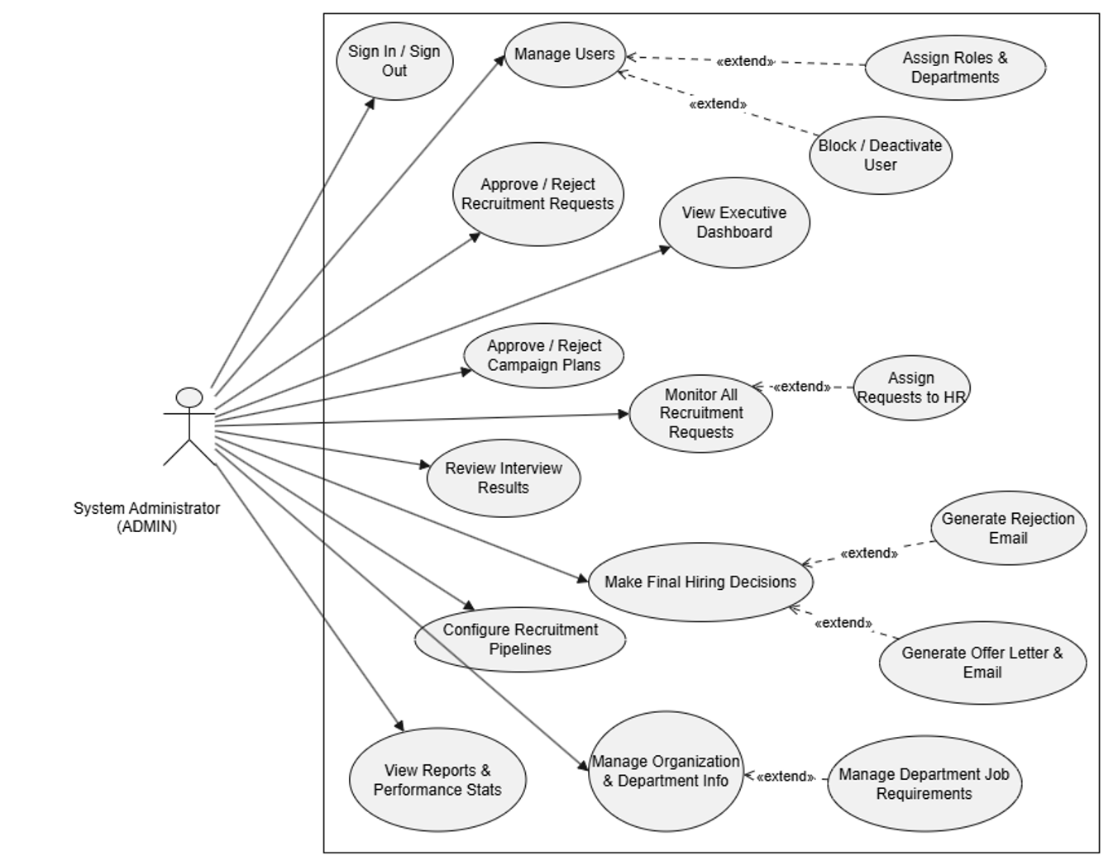

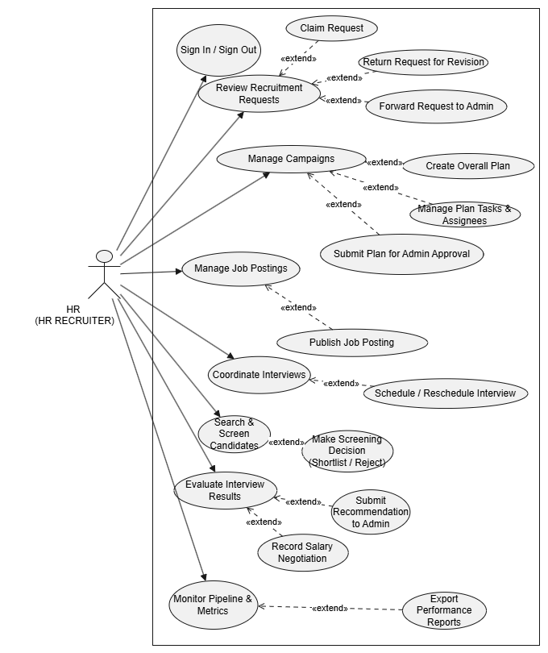
RMS - Use case Diagram: Common and Enterprise Modules

RMS - Use case Diagram: Candidate Module

b. Descriptions

ID | Feature | Use Case | Use Case Description
01 | Menu Operations | View Home Page | Display the system home page.
02 | Authentication | Login with Email/Password | Allow users to log into the system using email and password.
03 | Authentication | Login with Google Account | Allow users to log into the system using a Google account.
04 | Authentication | Logout | Allow users to securely log out of the system.
05 | Candidate Account | Register Candidate Account | Allow candidates to create a new account.
06 | Candidate Account | Verify OTP | Verify candidate registration using OTP.
07 | Candidate Profile | Upload Profile | Allow candidates to upload personal profile information.
08 | Candidate Profile | Upload CV | Allow candidates to upload or update their CV.
09 | Job Search | View Open Positions | Display available recruitment positions.
10 | Job Application | Submit Application | Allow candidates to apply for a recruitment position.
11 | Job Application | Screen CV | Screen submitted CVs before further processing.
12 | Job Offer | View Job Offer Details | Allow candidates to view offer information.
13 | Recruitment Request | Create Recruitment Request | Allow Department Head to create a recruitment request.
14 | Recruitment Request | Submit Recruitment Request | Allow Department Head to submit the request to HR.
15 | Recruitment Request | Track Recruitment Progress | Allow Department Head to track recruitment request status.
16 | HR Management | Receive Assigned Requests | Allow HR Leader to receive assigned recruitment requests.
17 | HR Management | Create Recruitment Campaign | Allow HR Leader to create a recruitment campaign for approved requests.
18 | Candidate Management | Manage Candidate Profile | Allow HR/Admin to manage candidate information.
19 | Recruitment Approval | Approve Recruitment Request | Allow Admin to approve recruitment requests.
20 | Recruitment Approval | Reject Recruitment Request | Allow Admin to reject recruitment requests.
21 | Request Management | View Recruitment Requests | Display the list of recruitment requests.
22 | Recruitment Management | Update Recruitment Request | Allow HR to modify recruitment request information.
23 | Notification | Send Recruitment Notification | Notify users about request or application status.
24 | Reporting | View Recruitment Report | Display recruitment progress and summary reports.

2. Overall Functionalities

2.1 Screens Flow

Actor Admin
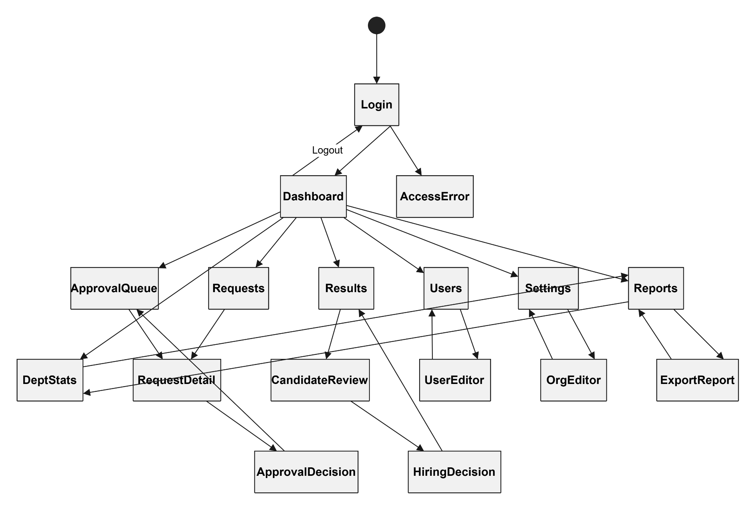

Actor Department Head
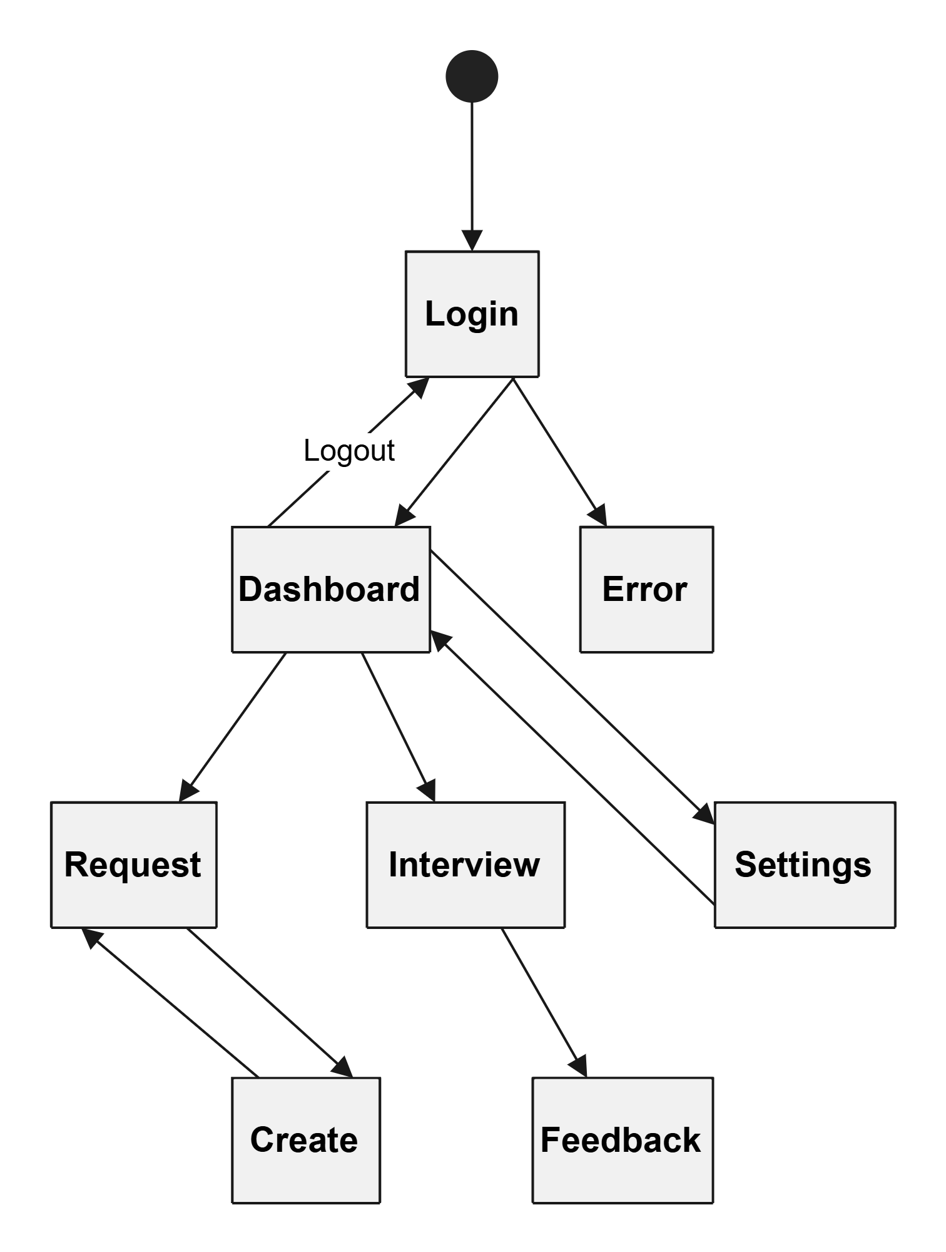

Actor HR Manager
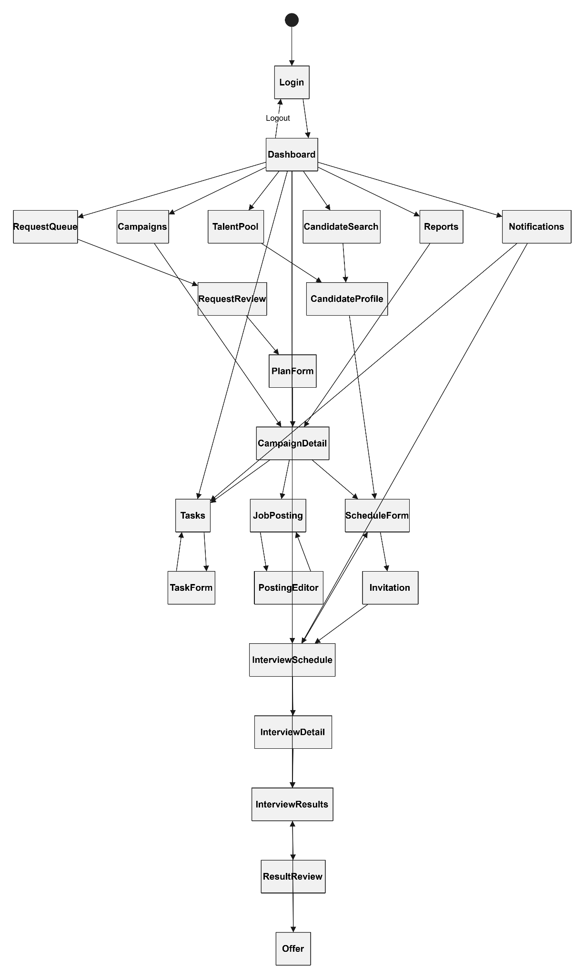

Actor Candidate
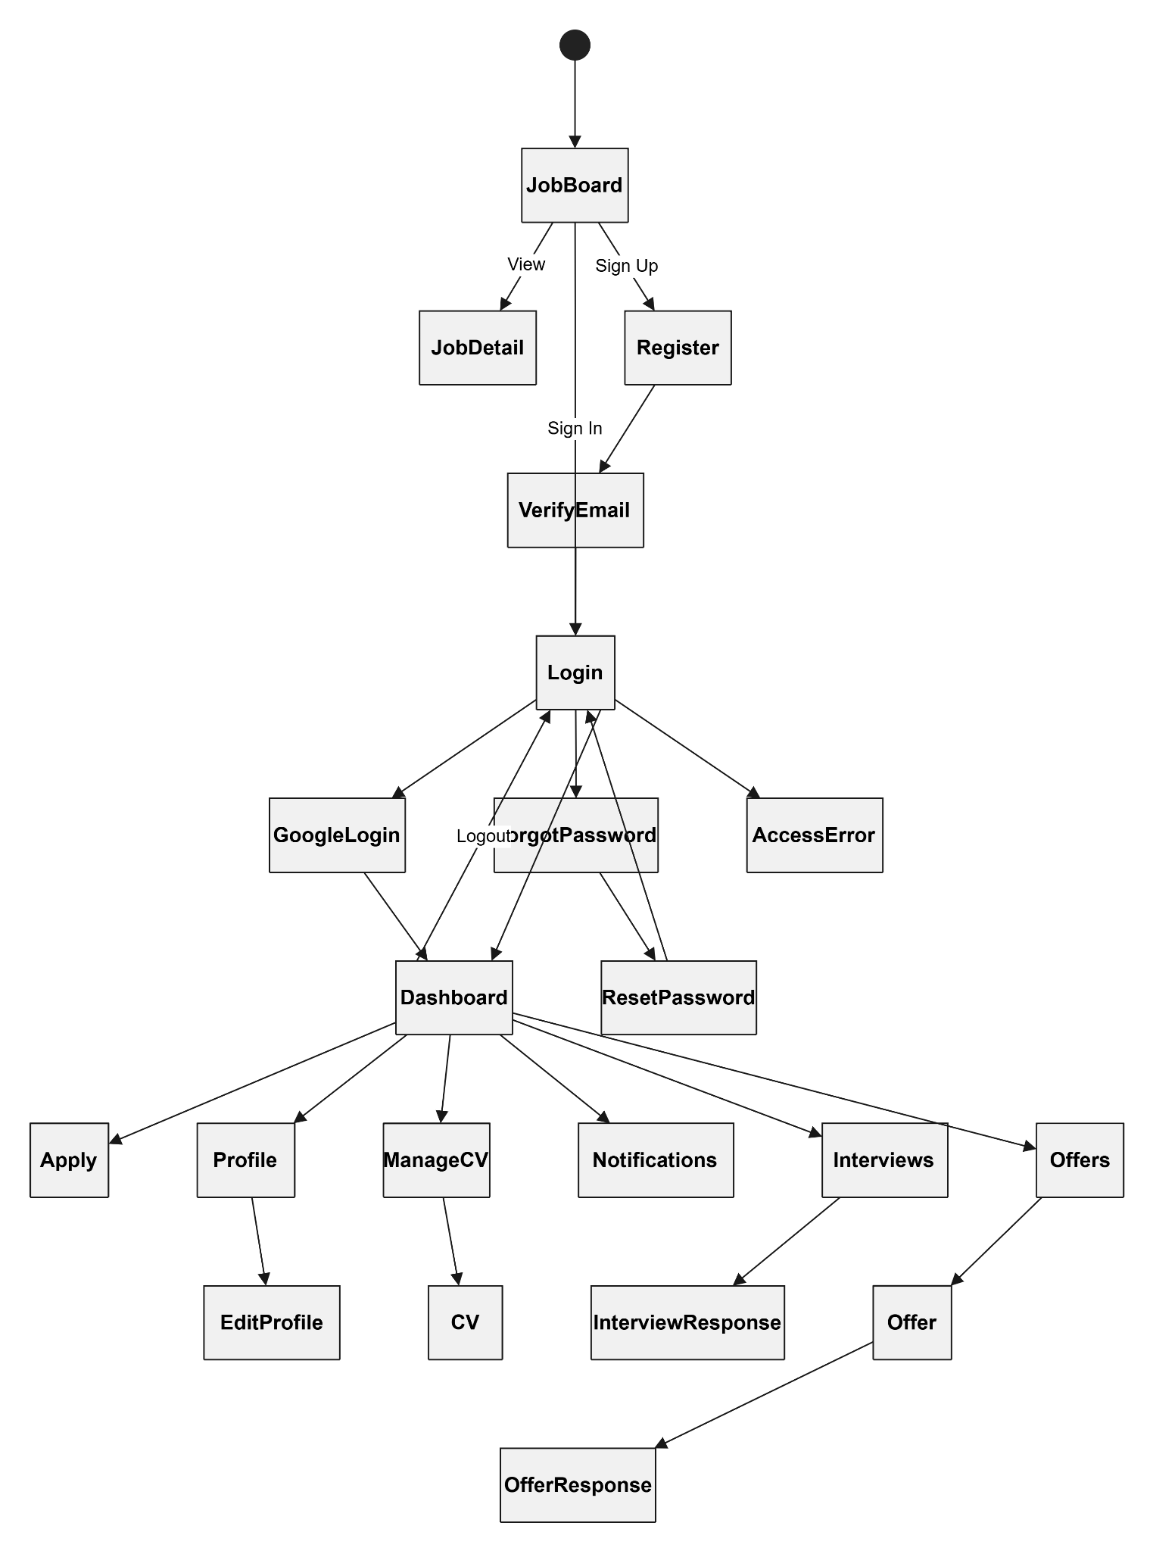

2.2 Screen Descriptions
# | Feature | Screen | Description
1 | Authentication | Login | Allow users to log into the system.
2 | Authentication | Register | Allow candidates to create an account.
3 | Authentication | Verify Email | Verify candidate email before activation.
4 | Authentication | Google Login | Allow users to sign in with Google.
5 | Authentication | Forgot Password | Allow users to request a password reset.
6 | Authentication | Reset Password | Allow users to create a new password.
7 | Authentication | Access Error | Display unauthorized or invalid access messages.
8 | Dashboard | Dashboard | Display the main navigation and overview information.
9 | Recruitment Request | Request | Display recruitment requests.
10 | Recruitment Request | Create Request | Create a new recruitment request.
11 | Recruitment Request | Approval Queue | Display pending recruitment requests for approval.
12 | Recruitment Request | Request Detail | Display recruitment request details.
13 | Recruitment | Campaigns | Manage recruitment campaigns.
14 | Recruitment | Campaign Detail | Display campaign information.
15 | Recruitment | Job Posting | Manage job postings.
16 | Candidate | Candidate Search | Search candidates.
17 | Candidate | Candidate Profile | Display candidate information.
18 | Candidate | Talent Pool | Manage candidate pool.
19 | Candidate | Apply | Submit a job application.
20 | Candidate | Profile | View candidate profile.
21 | Candidate | Edit Profile | Update candidate information.
22 | Candidate | Manage CV | Upload and manage CVs.
23 | Candidate | CV | Display uploaded CV information.
24 | Interview | Interview Schedule | Manage interview schedules.
25 | Interview | Interview Detail | Display interview details.
26 | Interview | Interview Response | Respond to interview invitations.
27 | Interview | Interview Results | Display interview results.
28 | Interview | Result Review | Review interview outcomes.
29 | Offer | Offer | Display job offers.
30 | Offer | Offer Response | Accept or reject job offers.
31 | Administration | Users | Manage system users.
32 | Administration | User Editor | Create or edit user accounts.
33 | Administration | Settings | Configure system settings.
34 | Administration | Organization Editor | Manage organization information.
35 | Reports | Reports | Display recruitment reports.
36 | Reports | Export Report | Export reports.
37 | Reports | Department Statistics | Display department statistics.
38 | Task Management | Tasks | Display assigned tasks.
39 | Task Management | Task Form | Create or update tasks.
40 | Notification | Notifications | Display system notifications.

2.3 Screen Authorization
Screen | Candidate | Department Head | HR Leader | Admin
Login | X | X | X | X
Register | X
Verify Email | X
Google Login | X | X | X | X
Dashboard | X | X | X | X
Apply | X
Profile | X
Edit Profile | X
Manage CV | X
Interview Response | X
Offer | X
Offer Response | X
Request |  | X | X | X
Create Request |  | X
Approval Queue |  |  |  | X
Request Detail |  | X | X | X
Campaigns |  |  | X
Campaign Detail |  |  | X
Job Posting |  |  | X
Candidate Search |  |  | X
Candidate Profile |  |  | X | X
Talent Pool |  |  | X
Interview Schedule |  |  | X
Interview Detail |  |  | X
Interview Results |  |  | X | X
Result Review |  |  | X | X
Users |  |  |  | X
User Editor |  |  |  | X
Settings |  | X | X | X
Organization Editor |  |  |  | X
Reports |  |  | X | X
Export Report |  |  |  | X
Department Statistics |  |  |  | X
Tasks |  |  | X
Task Form |  |  | X
Notifications | X | X | X | X

2.4 Non-UI Functions
# | Feature | System Function | Description
1 | Authentication | Email Verification Service | Send OTP verification emails.
2 | Authentication | Google OAuth Service | Authenticate users with Google.
3 | Authentication | Password Reset Service | Send password reset emails.
4 | Recruitment | Request Assignment Service | Assign requests to HR.
5 | Recruitment | Status Update Service | Update recruitment status automatically.
6 | Candidate | CV Parsing Service | Extract information from CVs.
7 | Candidate | Candidate Matching Service | Match candidates with jobs.
8 | Interview | Interview Notification Service | Send interview invitations.
9 | Offer | Offer Notification Service | Notify candidates of offers.
10 | Notification | Email Notification Service | Send system notifications.
11 | Reporting | Report Generation Service | Generate recruitment reports.
12 | Reporting | Report Export Service | Export reports to PDF/Excel.
13 | System | Audit Logging | Record user activities.
14 | System | Scheduled Backup | Perform automatic backups.
15 | System | Dashboard Statistics Service | Calculate dashboard statistics.

3. System High Level Design

3.1 Database Design

a. Database Schema
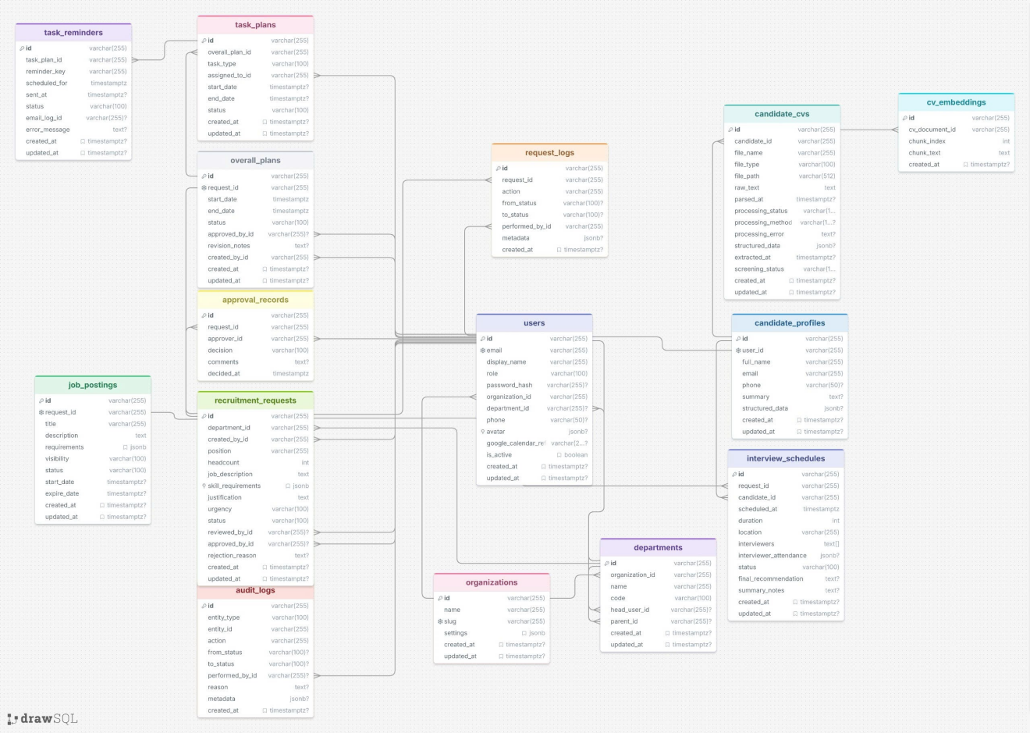

b. Table Descriptions

No | Table | Description
01 | applications | Tracks a candidate collected/submitted for a specific recruitment_requests row (e.g. via a CV-collection task), including who collected it and the application status.  Primary keys: id  Foreign keys: request_id (references recruitment_requests.id), candidate_id (references candidate_profiles.id), collected_by_id (references users.id)  Note: UNIQUE (request_id, candidate_id) prevents a candidate applying twice to the same request.
02 | approval_records | Records each individual approve/reject/revision-needed decision made on a recruitment_requests row, with the approver and their comments.  Primary keys: id  Foreign keys: request_id (references recruitment_requests.id), approver_id (references users.id)
03 | candidate_cvs | An uploaded CV file for a candidate — raw extracted text plus the AI-parsing pipeline state (processing_status, processing_method, processing_error, structured_data, extracted_at, screening_status).  Primary keys: id  Foreign keys: candidate_id (references candidate_profiles.id)
04 | candidate_profiles | The candidate's profile record, 1-to-1 with a user account — contact info and AI-structured CV data.  Primary keys: id  Foreign keys: user_id (references users.id, unique)
05 | cv_embeddings | Per-chunk text embeddings generated from a CV document, used for vector-based candidate search/matching.  Primary keys: id  Foreign keys: cv_document_id (references candidate_cvs.id)
06 | departments | A department within an organization; self-referencing parent/child hierarchy, with an optional head user.  Primary keys: id  Foreign keys: organization_id (references organizations.id), head_user_id (references users.id), parent_id (references departments.id — self-reference)
07 | email_logs | Log of every email the system attempts to send — recipient, subject, body, delivery status, error message.  Primary keys: id  Foreign keys: user_id (references users.id, nullable)
08 | interview_results | The outcome of a completed interview — result, notes, evaluator, and per-criterion scores (technical, communication, culture).  Primary keys: id  Foreign keys: interview_id (references interview_schedules.id), evaluator_id (references users.id)
09 | interview_schedules | A scheduled interview for a candidate against a recruitment request — time/duration/location/interviewers, attendance tracking, final recommendation and summary notes.  Primary keys: id  Foreign keys: request_id (references recruitment_requests.id), candidate_id (references candidate_profiles.id)
10 | job_postings | The published job posting for a recruitment_requests row — title, description, requirements, visibility, publish window (start_date / expire_date), and status.  Primary keys: id  Foreign keys: request_id (references recruitment_requests.id, unique — one posting per request)
11 | notifications | In-app notifications delivered to a user, optionally linked to a related entity (related_entity_id / related_entity_type).  Primary keys: id  Foreign keys: user_id (references users.id)
12 | offer_letters | An offer letter generated and sent to a candidate for a recruitment_requests row — compensation, position/department snapshot, delivery tracked via email_logs, and the candidate's response.  Primary keys: id  Foreign keys: request_id (references recruitment_requests.id), candidate_id (references candidate_profiles.id), generated_by_id (references users.id), email_log_id (references email_logs.id)
13 | organizations | The top-level tenant/company using the system — name, unique slug, and JSONB settings.  Primary keys: id  Foreign keys: none (root entity)
14 | overall_plans | The overall recruitment plan for a recruitment_requests row — timeline and approval status; parent of task_plans.  Primary keys: id  Foreign keys: request_id (references recruitment_requests.id, unique), approved_by_id (references users.id), created_by_id (references users.id)
15 | recruitment_requests | The core hiring-request record created by a Department Head — position, headcount, JD, skill requirements, urgency, and its review/approval chain.  Primary keys: id  Foreign keys: department_id (references departments.id); created_by_id, reviewed_by_id, approved_by_id (all reference users.id)
16 | request_logs | Audit trail of status transitions and actions performed on a recruitment_requests row.  Primary keys: id  Foreign keys: request_id (references recruitment_requests.id), performed_by_id (references users.id)
17 | talent_search_feedback | HR feedback/interaction captured against one candidate within a Talent Search run — rank shown, action taken, and the score breakdown (overall / vector / graph / coverage); used to evaluate and tune the matching algorithm.  Primary keys: id  Foreign keys: search_run_id (references talent_search_runs.id), candidate_id (references candidate_profiles.id), actor_user_id (references users.id), request_id (references recruitment_requests.id)
18 | talent_search_runs | A log of a single Talent Search execution — the actor, query text, filters, graph-expanded skills, result count, and scoring model version used.  Primary keys: id  Foreign keys: actor_user_id (references users.id), request_id (references recruitment_requests.id)
19 | task_plans | An individual task within an overall_plans row assigned to an HR staff member (e.g. JOB_POSTING, CV_COLLECTION, CV_SCREENING, INTERVIEW_COORDINATION).  Primary keys: id  Foreign keys: overall_plan_id (references overall_plans.id), assigned_to_id (references users.id)
20 | task_reminders | A scheduled reminder tied to a task_plans row (e.g. an approaching deadline), tracked through to email delivery via email_logs.  Primary keys: id  Foreign keys: task_plan_id (references task_plans.id), email_log_id (references email_logs.id)
21 | users | System user accounts (Admin, Department Head, HR Manager, Candidate) — credentials, role, org/department membership, avatar, and an optional Google Calendar refresh token for interview sync.  Primary keys: id  Foreign keys: organization_id (references organizations.id), department_id (references departments.id)

3.2 Code Packages
[Provide the package diagram for each sub-system. The content of this section including the overall package diagram, the explanation, package and class naming conventions in each package. Please see the sample & description table format below]
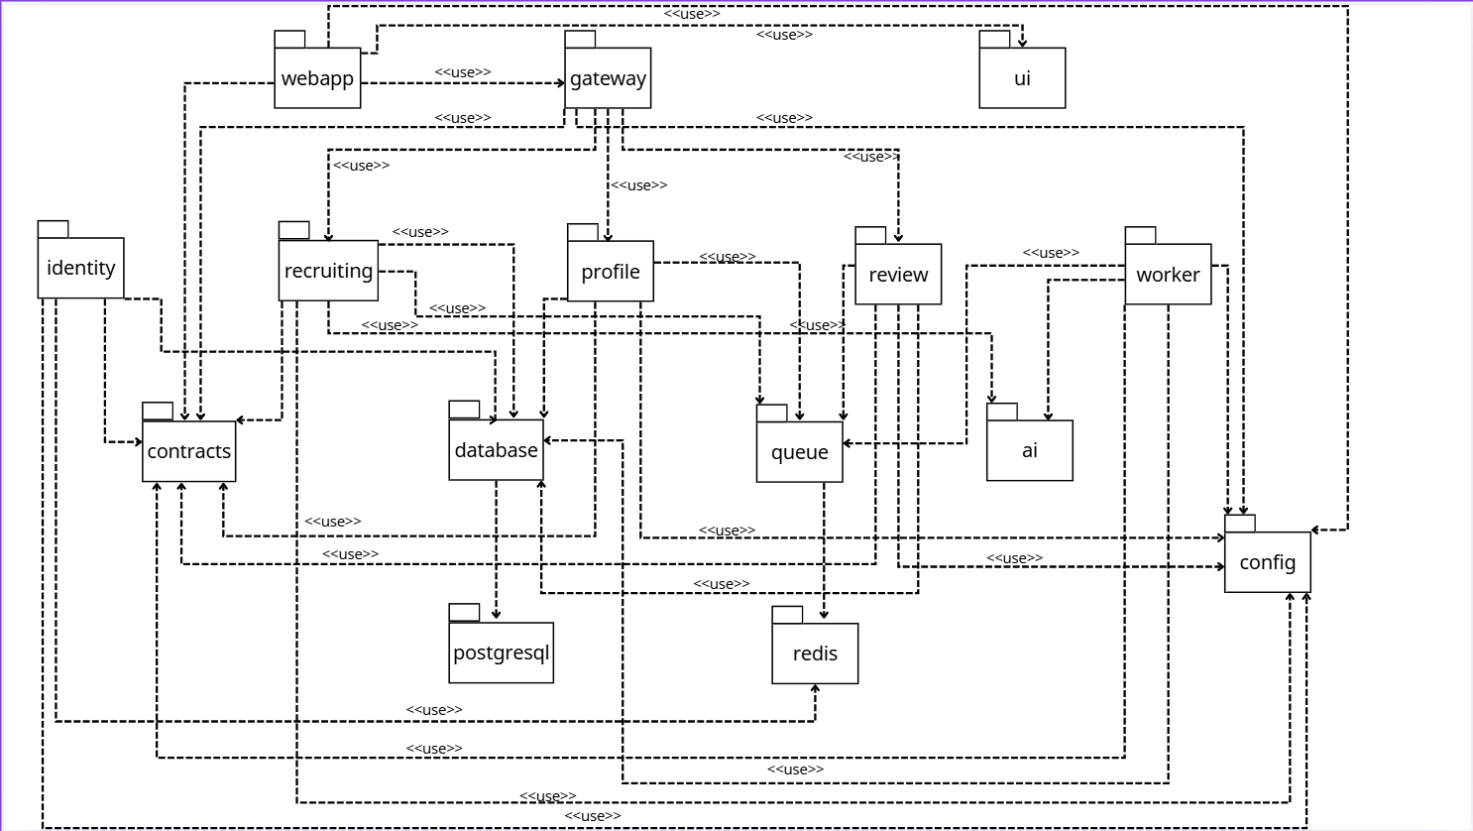
Package descriptionsPackage descriptions
No | Package | Description
01 | @wr/webapp (webapp/) | React 19 + React Router v7 + Vite SPA. Implements the role-based authenticated shell (sidebar/layout), auth context, protected routing, and per-role dashboards. Dev server :3000, proxies /api to the gateway.
02 | @wr/gateway (services/gateway) | Single public HTTP entry point (port 3001, prefix /api/v1). Terminates JWT auth (JwtAuthGuard) and RBAC (RolesGuard), exposes Swagger at /api/docs, and proxies every request as a TCP ClientProxy.send() call to the relevant downstream service. Contains no business logic — thin proxy controllers only.
03 | @wr/identity (services/identity) | Auth (register/login/refresh/logout/forgot-reset password), Users CRUD + role/status management, Organizations CRUD, Departments CRUD with hierarchy. Owns Redis-backed refresh tokens and password-reset codes. TCP listener on port 3010.
04 | @wr/recruiting (services/recruiting) | Core recruitment workflow domain: Roles/JDs, Applications, Invites, Evaluations, Talent Search, and Interviews (schedule/reschedule/cancel/record result). TCP listener on port 3011.
05 | @wr/profiles (services/profiles) | Candidate profile data, uploaded documents (CV/JD), and extracted evidence records. TCP listener on port 3012.
06 | @wr/review (services/review) | Reviewer feedback and decision “packets” (candidate decision bundles for approval). TCP listener on port 3013.
07 | @wr/worker (services/worker) | Background job processing via BullMQ/Redis: CV parsing, embedding generation, email sending. Mostly stub processors today, except the embedding processor.
08 | @wr/contracts (packages/contracts) | Cross-service source of truth: domain enums, Zod validation schemas, shared API types. Imported by every service and the webapp.
09 | @wr/database (packages/database) | Prisma schema and generated PrismaClient, shared by every backend service.
10 | @wr/config (packages/config) | Shared runtime configuration helpers (env parsing, etc.).
11 | @wr/queue (packages/queue) | BullMQ queue name constants shared between producers (recruiting/profiles/review) and the consumer (worker).
12 | @wr/ai (packages/ai) | Legacy-in-transition AI/matching toolkit: CV parsing, embeddings, skill knowledge graph, matching/scoring engine. Consumed by recruiting (talent search) and worker (embeddings).
13 | @wr/ui (packages/ui) | Shared React design-system primitives and design tokens, consumed by webapp.
14 | @wr/typescript-config | Shared tsconfig bases only, no runtime code.

II. Requirement Specifications

1. Auth

1.1 UC-01_Register Account

a. Functionalities
Provide the functional description for the use cases using the template/guides below
Functional Description Template
UC ID and Name: | UC-01 - Register Account
Created By: | Thanh Phong | Date Created: | 2026-07-06
Primary Actor: | Candidate | Secondary Actors: | N/A
Trigger: | Candidate opens Sign Up and submits registration information.
Description: | Creates a new account request and starts email verification.
Preconditions: | Candidate is not logged in; email is not already registered.
Postconditions: | Account registration data is stored; OTP is sent.
Normal Flow: | 1. Candidate opens Sign Up.  2. Candidate enters display name, email, password and account type.  3. System validates input.  4. System creates pending account / registration state.  5. System sends OTP email.
Alternative Flows: | A1. Candidate signs up with supported Supabase/Google session.
Exceptions:
Priority: | High (Medium, Low), Must Have (Should Have, Could Have),..
Frequency of Use: | High.
Business Rules: | BR-01, BR-02
Other Information: | Module / Feature: Auth. Trace: POST /api/v1/auth/register, POST /api/v1/auth/supabase-register
Assumptions: | User has appropriate account status, role permission, and organization/department scope where applicable.

Functional Description Contents
Use Case ID and Name
Give each use case a unique integer sequence number identifier. State a concise name for the use case that indicates the value the use case would provide to some user. Begin with an action verb, followed by an object.
Author and Date Created
Enter the name of the person who initially wrote this use case and the date it was written.
Primary and Secondary Actors
An actor is a person or other entity external to the software system being specified who interacts with the system and performs use cases to accomplish tasks. Different actors often correspond to different user classes, or roles, identified from the customer community that will use the product. Name the primary actor that will be initiating this use case and any other secondary actors who will participate in completing execution of the use case.
Trigger
Identify the business event, system event, or user action that initiates the use case. This trigger alerts the system that it should begin testing the preconditions for the use case so it can judge whether to proceed with execution.
Description
Provide a brief description of the reason for and outcome of this use case, or a high-level description of the sequence of actions and the outcome of executing the use case.
Preconditions
List any activities that must take place, or any conditions that must be true, before the use case can be started. The system must be able to test each precondition. Number each precondition. Example: PRE-1: User’s identity has been authenticated.
Postconditions
Describe the state of the system at the successful conclusion of the use case execution. Label each postcondition in the form POST-X, where X is a sequence number. Example: POST-1: Price of item in the database has been updated with the new value.
Normal Flow
Provide a description of the user actions and corresponding system responses that will take place during execution of the use case under normal, expected conditions. This dialog sequence will ultimately lead to accomplishing the goal stated in the use case name and description. Show a numbered list of actions performed by the actor, alternating with responses provided by the system. The normal flow is numbered “X.0”, where “X” is the Use Case ID.
Alternative Flows
Document other successful usage scenarios that can take place within this use case. State the alternative flow, and describe any differences in the sequence of steps that take place. Number each alternative flow in the form “X.Y”, where “X” is the Use Case ID and Y is a sequence number for the alternative flow. For example, “5.3” would indicate the third alternative flow for use case number 5. Indicate where each alternative flow would branch off from the normal flow, and if pertinent, where it would rejoin the normal flow.
Exceptions
Describe any anticipated error conditions that could occur during execution of the use case and how the system is to respond to those conditions. Number each alternative flow in the form “X.Y.EZ”, where “X” is the Use Case ID, Y indicates the normal (0) or alternative (>0) flow during which this exception could take place, “E” indicates an exception, and “Z” is a sequence number for the exceptions. For example “5.0.E2” would indicate the second exception for the normal flow for use case number 5. Indicate where in the normal (or an alternative) flow each exception could occur.
Priority
Indicate the relative priority of implementing the functionality required to allow this use case to be executed. Use the same priority scheme as that used for the functional requirements.
Frequency of Use
Estimate the number of times this use case will be performed per some appropriate unit of time. This gives an early indicator of throughput, concurrent usage loads, and transaction capacity.
Business Rules
List any business rules that influence this use case. Don’t include the business rule text here, just its identifier so the reader can find it in another repository when needed.
Other Information
Identify any additional requirements, such as quality attributes, for the use case that may need to be addressed during design or implementation. Also list any associated functional requirements that aren’t a direct part of the use case flows but which a developer needs to know about. Describe what should happen if the use case execution fails for some unanticipated or systemic reason (e.g., loss of network connectivity, timeout). If the use case results in a durable state change in a database or the outside world, state whether the change is rolled back, completed correctly, partially completed with a known state, or left in an undetermined state as a result of the exception.
Assumptions
List any assumptions that were made regarding this use case or how it might execute.

b. Business Rules
Provide the business rules those are applied only to the use case
ID | Business Rule | Business Rule Description
FR1 | Password Encoding | User’s password must be encoded with MD5 hashing

1.2 UC-02_Verify Registration Email / Resend OTP

a. Functionalities
Provide the functional description for the use case using the template below.
Functional Description Template
UC ID and Name: | UC-02 - Verify Registration Email / Resend OTP
Created By: | Thanh Phong | Date Created: | 2026-07-06
Primary Actor: | Candidate | Secondary Actors: | N/A
Trigger: | Candidate enters OTP from email or requests a new OTP.
Description: | Confirms email ownership and activates registration.
Preconditions: | Candidate submitted registration and OTP exists.
Postconditions: | Account is verified; user may log in or continue session.
Normal Flow: | 1. Candidate opens OTP verification screen.  2. Candidate enters OTP.  3. System validates code and expiry.  4. System activates account.
Alternative Flows: | A1. Candidate requests resend OTP; system sends a new code if allowed.
Exceptions: | E1. OTP invalid.  E2. OTP expired.  E3. Email delivery fails.
Priority: | Must Have
Frequency of Use: | High
Business Rules: | BR-01, BR-02
Other Information: | Module / Feature: Auth. Trace: POST /api/v1/auth/verify-register, POST /api/v1/auth/resend-register-otp
Assumptions: | User has appropriate account status, role permission, and organization/department scope where applicable.

b. Business Rules
None

1.3 UC-03_Login

a. Functionalities
Provide the functional description for the use case using the template below.
Functional Description Template
UC ID and Name: | UC-03 - Login
Created By: | Thanh Phong | Date Created: | 2026-07-06
Primary Actor: | Admin | Secondary Actors: | HR, Department Head, Candidate
Trigger: | User submits email/password.
Description: | Authenticates the user and routes to the role-specific dashboard.
Preconditions: | User account exists and is active.
Postconditions: | Access token and refresh token are issued.
Normal Flow: | 1. User opens Login.  2. User enters credentials.  3. System validates credentials.  4. System returns token pair and user profile.  5. Frontend redirects by role.
Alternative Flows: | A1. User chooses password reset instead of login.
Exceptions: | E1. Invalid credentials.  E2. Inactive account.  E3. Unknown/unauthorized role.
Priority: | Must Have
Frequency of Use: | High
Business Rules: | BR-01, BR-02
Other Information: | Module / Feature: Auth. Trace: POST /api/v1/auth/login
Assumptions: | User has appropriate account status, role permission, and organization/department scope where applicable.

b. Business Rules
None

1.4 UC-04_Login/Register with Supabase or Google Session

a. Functionalities
Provide the functional description for the use case using the template below.
Functional Description Template
UC ID and Name: | UC-04 - Login/Register with Supabase or Google Session
Created By: | Thanh Phong | Date Created: | 2026-07-06
Primary Actor: | Admin | Secondary Actors: | HR, Department Head, Candidate
Trigger: | User continues authentication through Supabase/Google-backed session.
Description: | Completes login or registration using external identity session data.
Preconditions: | Supabase/Google provider is configured; session is valid.
Postconditions: | User profile is matched or created; token/session state is established.
Normal Flow: | 1. User selects Google/Supabase sign-in.  2. Provider authenticates user.  3. System receives session/profile.  4. System matches existing user or completes registration.
Alternative Flows: | A1. Existing Google user is routed directly to dashboard.
Exceptions: | E1. Account not registered.  E2. Provider session invalid.
Priority: | Must Have
Frequency of Use: | High
Business Rules: | BR-01, BR-02
Other Information: | Module / Feature: Auth. Trace: POST /api/v1/auth/supabase-login, POST /api/v1/auth/supabase-register
Assumptions: | User has appropriate account status, role permission, and organization/department scope where applicable.

b. Business Rules
None

1.5 UC-05_Refresh Session

a. Functionalities
Provide the functional description for the use case using the template below.
Functional Description Template
UC ID and Name: | UC-05 - Refresh Session
Created By: | Thanh Phong | Date Created: | 2026-07-06
Primary Actor: | Authenticated User | Secondary Actors: | N/A
Trigger: | Access token expires while refresh token is still valid.
Description: | Issues a new token pair without requiring the user to log in again.
Preconditions: | Refresh token exists and has not expired/revoked.
Postconditions: | New access/refresh token pair is issued; old refresh token is rotated.
Normal Flow: | 1. Client sends refresh token.  2. System verifies token hash/TTL.  3. System loads user.  4. System rotates token pair.
Alternative Flows: | A1. User cancels the "Refresh Session" action before submission; system keeps the previous state unchanged.  A2. Required context is missing or incomplete; system guides the actor back to the related Auth screen to complete prerequisite information.  A3. Actor opens the action from a dashboard, notification or detail page; system resolves the same use case using the selected record context.
Exceptions: | E1. Refresh token expired.  E2. User no longer exists.
Priority: | Must Have
Frequency of Use: | High
Business Rules: | BR-01, BR-02
Other Information: | Module / Feature: Auth. Trace: POST /api/v1/auth/refresh
Assumptions: | User has appropriate account status, role permission, and organization/department scope where applicable.

b. Business Rules
None

1.6 UC-06_Logout

a. Functionalities
Provide the functional description for the use case using the template below.
Functional Description Template
UC ID and Name: | UC-06 - Logout
Created By: | Thanh Phong | Date Created: | 2026-07-06
Primary Actor: | Authenticated User | Secondary Actors: | N/A
Trigger: | User selects Logout.
Description: | Ends the active session and revokes refresh token state.
Preconditions: | User has an active session.
Postconditions: | Refresh token is invalidated; client clears session data.
Normal Flow: | 1. User clicks Logout.  2. Client calls logout endpoint.  3. System invalidates refresh token.  4. Frontend redirects to public page/login.
Alternative Flows: | A1. User cancels the "Logout" action before submission; system keeps the previous state unchanged.  A2. Required context is missing or incomplete; system guides the actor back to the related Auth screen to complete prerequisite information.  A3. Actor opens the action from a dashboard, notification or detail page; system resolves the same use case using the selected record context.
Exceptions: | E1. Token already invalid; user is still logged out locally.
Priority: | Must Have
Frequency of Use: | High
Business Rules: | BR-01, BR-02
Other Information: | Module / Feature: Auth. Trace: POST /api/v1/auth/logout
Assumptions: | User has appropriate account status, role permission, and organization/department scope where applicable.

b. Business Rules
None

1.7 UC-07_Reset Password

a. Functionalities
Provide the functional description for the use case using the template below.
Functional Description Template
UC ID and Name: | UC-07 - Reset Password
Created By: | Thanh Phong | Date Created: | 2026-07-06
Primary Actor: | Any User | Secondary Actors: | N/A
Trigger: | User selects Forgot Password or submits reset OTP.
Description: | Sends password reset OTP and updates password after verification.
Preconditions: | Email belongs to a user account.
Postconditions: | Password hash is updated; user can log in with new password.
Normal Flow: | 1. User requests password reset.  2. System sends OTP.  3. User enters OTP and new password.  4. System validates and updates password.
Alternative Flows: | A1. Any User cancels the "Reset Password" action before submission; system keeps the previous state unchanged.  A2. Required context is missing or incomplete; system guides the actor back to the related Auth screen to complete prerequisite information.  A3. Actor opens the action from a dashboard, notification or detail page; system resolves the same use case using the selected record context.
Exceptions: | E1. Unknown email.  E2. OTP invalid/expired.  E3. Password fails validation.
Priority: | Must Have
Frequency of Use: | High
Business Rules: | BR-01, BR-02
Other Information: | Module / Feature: Auth. Trace: POST /api/v1/auth/forgot-password, POST /api/v1/auth/reset-password
Assumptions: | User has appropriate account status, role permission, and organization/department scope where applicable.

b. Business Rules
None

2. Identity
Related Use Cases: UC-08 View and Update Own Profile; UC-10 Manage Users and Roles; UC-11 Check User Email Availability; UC-12 Manage Organizations; UC-13 Manage Organization Settings; UC-14 Manage Departments; UC-15 Manage Department Team Members

b. Business Rules
None

2.1 UC-10_Manage Users and Roles

a. Functional Description
Provide the functional description for the use case using the template below.
Functional Description Template
UC ID and Name: | UC-10 - Manage Users and Roles
Created By: | Duy Hiếu | Date Created: | 2026-07-06
Primary Actor: | Admin | Secondary Actors: | N/A
Trigger: | Admin opens Users management.
Description: | Admin lists, creates, updates, deletes, activates/deactivates users, and changes roles.
Preconditions: | Admin is authenticated.
Postconditions: | User records and role/status settings are updated.
Normal Flow: | 1. Admin opens Users.  2. System lists users with filters.  3. Admin creates/updates user or role/status.  4. System validates and persists change.
Alternative Flows: | A1. Admin cancels the "Manage Users and Roles" action before submission; system keeps the previous state unchanged.  A2. Required context is missing or incomplete; system guides the actor back to the related Identity screen to complete prerequisite information.  A3. Actor opens the action from a dashboard, notification or detail page; system resolves the same use case using the selected record context.
Exceptions: | E1. Email duplicate.  E2. Invalid role.  E3. User not found.
Priority: | Must Have
Frequency of Use: | Medium
Business Rules: | BR-01, BR-02
Other Information: | Module / Feature: Identity. Trace: GET /api/v1/users, POST /api/v1/users, GET /api/v1/users/:id, PATCH /api/v1/users/:id, DELETE /api/v1/users/:id, PATCH /api/v1/users/:id/role, PATCH /api/v1/users/:id/status
Assumptions: | User has appropriate account status, role permission, and organization/department scope where applicable.

b. Business Rules
None

2.2 UC-11_Check User Email Availability

a. Functional Description
Provide the functional description for the use case using the template below.
Functional Description Template
UC ID and Name: | UC-11 - Check User Email Availability
Created By: | Duy Hiếu | Date Created: | 2026-07-06
Primary Actor: | Admin | Secondary Actors: | Public Registration Flow
Trigger: | Email field needs uniqueness validation.
Description: | Checks whether an email already belongs to an existing user.
Preconditions: | Email input is provided.
Postconditions: | Availability/exists result is returned.
Normal Flow: | 1. Client submits email.  2. System validates email format.  3. System checks user table.  4. System returns result.
Alternative Flows: | A1. Admin cancels the "Check User Email Availability" action before submission; system keeps the previous state unchanged.  A2. Required context is missing or incomplete; system guides the actor back to the related Identity screen to complete prerequisite information.  A3. Actor opens the action from a dashboard, notification or detail page; system resolves the same use case using the selected record context.
Exceptions: | E1. Invalid email format.
Priority: | Must Have
Frequency of Use: | Medium
Business Rules: | BR-01, BR-02
Other Information: | Module / Feature: Identity. Trace: GET /api/v1/users/email-exists
Assumptions: | User has appropriate account status, role permission, and organization/department scope where applicable.

b. Business Rules
None

2.3 UC-12_Manage Organizations

a. Functional Description
Provide the functional description for the use case using the template below.
Functional Description Template
UC ID and Name: | UC-12 - Manage Organizations
Created By: | Duy Hiếu | Date Created: | 2026-07-06
Primary Actor: | Admin | Secondary Actors: | N/A
Trigger: | Admin opens organization administration.
Description: | Creates, lists, views and updates organizations.
Preconditions: | Admin is authenticated.
Postconditions: | Organization data is persisted.
Normal Flow: | 1. Admin opens Organizations.  2. System lists records.  3. Admin creates or edits organization.  4. System validates and saves.
Alternative Flows: | A1. Admin cancels the "Manage Organizations" action before submission; system keeps the previous state unchanged.  A2. Required context is missing or incomplete; system guides the actor back to the related Identity screen to complete prerequisite information.  A3. Actor opens the action from a dashboard, notification or detail page; system resolves the same use case using the selected record context.
Exceptions: | E1. Duplicate slug/name.  E2. Organization not found.
Priority: | Must Have
Frequency of Use: | Medium
Business Rules: | BR-01, BR-02
Other Information: | Module / Feature: Identity. Trace: POST /api/v1/organizations, GET /api/v1/organizations, GET /api/v1/organizations/:id, PATCH /api/v1/organizations/:id
Assumptions: | User has appropriate account status, role permission, and organization/department scope where applicable.

b. Business Rules
None

2.4UC-13_Manage Organization Settings

a. Functionalities
Provide the functional description for the use case using the template below.
Functional Description Template
UC ID and Name: | UC-13 - Manage Organization Settings
Created By: | Duy Hiếu | Date Created: | 2026-07-06
Primary Actor: | Admin | Secondary Actors: | N/A
Trigger: | Admin updates configurable organization settings.
Description: | Stores organization-level settings used by workflows and UI.
Preconditions: | Organization exists; Admin is authenticated.
Postconditions: | Settings JSON is updated.
Normal Flow: | 1. Admin opens settings.  2. Admin updates setting values.  3. System validates payload.  4. System persists settings.
Alternative Flows: | A1. Admin cancels the "Manage Organization Settings" action before submission; system keeps the previous state unchanged.  A2. Required context is missing or incomplete; system guides the actor back to the related Identity screen to complete prerequisite information.  A3. Actor opens the action from a dashboard, notification or detail page; system resolves the same use case using the selected record context.
Exceptions: | E1. Organization not found.  E2. Invalid settings payload.
Priority: | Must Have
Frequency of Use: | Medium
Business Rules: | BR-01, BR-02
Other Information: | Module / Feature: Identity. Trace: PATCH /api/v1/organizations/:id/settings
Assumptions: | User has appropriate account status, role permission, and organization/department scope where applicable.

2.6 UC-14_Manage Departments

a. Functionalities
Provide the functional description for the use case using the template below.
Functional Description Template
UC ID and Name: | UC-14 - Manage Departments
Created By: | Duy Hiếu | Date Created: | 2026-07-06
Primary Actor: | Admin | Secondary Actors: | N/A
Trigger: | Admin opens department management.
Description: | Creates, lists, updates and deletes departments and department hierarchy/head.
Preconditions: | Admin is authenticated; organization exists.
Postconditions: | Department records are updated.
Normal Flow: | 1. Admin lists departments.  2. Admin creates/updates/deletes department.  3. System validates organization, code and head user.  4. System saves change.
Alternative Flows: | A1. Admin cancels the "Manage Departments" action before submission; system keeps the previous state unchanged.  A2. Required context is missing or incomplete; system guides the actor back to the related Identity screen to complete prerequisite information.  A3. Actor opens the action from a dashboard, notification or detail page; system resolves the same use case using the selected record context.
Exceptions: | E1. Duplicate department code.  E2. Invalid head user.  E3. Department not found.
Priority: | Must Have
Frequency of Use: | Medium
Business Rules: | BR-01, BR-02
Other Information: | Module / Feature: Identity. Trace: POST /api/v1/departments, GET /api/v1/departments, GET /api/v1/departments/:id, PATCH /api/v1/departments/:id, DELETE /api/v1/departments/:id
Assumptions: | User has appropriate account status, role permission, and organization/department scope where applicable.

2.5 UC-15_Manage Department Team Members

a. Functionalities
Provide the functional description for the use case using the template below.
Functional Description Template
UC ID and Name: | UC-15 - Manage Department Team Members
Created By: | Tuấn Dũng | Date Created: | 2026-07-06
Primary Actor: | Department Head | Secondary Actors: | N/A
Trigger: | Department Head updates department team settings.
Description: | Adds or manages department members in the department settings screen.
Preconditions: | Department Head is authenticated and owns/heads the department.
Postconditions: | Department member/user record is created or updated.
Normal Flow: | 1. Department Head opens Dept Settings.  2. Adds team member.  3. System validates department scope.  4. System creates member account/profile.
Alternative Flows: | A1. Department Head cancels the "Manage Department Team Members" action before submission; system keeps the previous state unchanged.  A2. Required context is missing or incomplete; system guides the actor back to the related Identity screen to complete prerequisite information.  A3. Actor opens the action from a dashboard, notification or detail page; system resolves the same use case using the selected record context.
Exceptions: | E1. Email already exists.  E2. Department scope violation.
Priority: | Must Have
Frequency of Use: | Medium
Business Rules: | BR-01, BR-02
Other Information: | Module / Feature: Identity. Trace: POST /api/v1/dept-head/settings/team-members
Assumptions: | User has appropriate account status, role permission, and organization/department scope where applicable.

3. Identity / Calendar
Related Use Cases: UC-09 Connect Google Calendar and Create Meet Link

3.1 UC-09_Connect Google Calendar and Create Meet Link

a. Functionalities
Provide the functional description for the use case using the template below.
Functional Description Template
UC ID and Name: | UC-09 - Connect Google Calendar and Create Meet Link
Created By: | Thanh Phong | Date Created: | 2026-07-06
Primary Actor: | Admin | Secondary Actors: | HR, Department Head
Trigger: | User requests calendar authorization or Meet link generation.
Description: | Supports Google Calendar integration for interview scheduling.
Preconditions: | User has internal role; Google integration env is configured.
Postconditions: | Calendar refresh token is stored or Meet link is created.
Normal Flow: | 1. User requests auth URL.  2. User completes OAuth callback.  3. System stores refresh token.  4. User creates Meet link for interview.
Alternative Flows: | A1. Admin cancels the "Connect Google Calendar and Create Meet Link" action before submission; system keeps the previous state unchanged.  A2. Required context is missing or incomplete; system guides the actor back to the related Identity / Calendar screen to complete prerequisite information.  A3. Actor opens the action from a dashboard, notification or detail page; system resolves the same use case using the selected record context.
Exceptions: | E1. OAuth callback invalid.  E2. Google API unavailable.
Priority: | Must Have
Frequency of Use: | Medium
Business Rules: | BR-01, BR-02
Other Information: | Module / Feature: Identity / Calendar. Trace: GET /api/v1/google-calendar/auth-url, GET /api/v1/oauth2callback, POST /api/v1/google-calendar/meet
Assumptions: | User has appropriate account status, role permission, and organization/department scope where applicable.

4. Recruiting
Related Use Cases: UC-16 Create Recruitment Request; UC-17 Update Recruitment Request; UC-18 Submit Recruitment Request; UC-19 Assign Recruitment Request to HR; UC-20 Return Recruitment Request for Revision; UC-21 Request Changes from HR; UC-22 Forward Recruitment Request to Admin; UC-23 Make Recruitment Request Decision; UC-32 Manage Roles / Job Descriptions

4.1 UC-16_Create Recruitment Request

a. Functionalities
Provide the functional description for the use case using the template below.
Functional Description Template
UC ID and Name: | UC-16 - Create Recruitment Request
Created By: | Thanh Phong | Date Created: | 2026-07-06
Primary Actor: | Department Head | Secondary Actors: | N/A
Trigger: | Department Head opens Create Request.
Description: | Creates a draft staffing request for a department.
Preconditions: | Department Head is authenticated and assigned to a department.
Postconditions: | Recruitment request is created in DRAFT or submitted state depending on payload/action.
Normal Flow: | 1. Actor enters position, headcount, urgency, requirements, JD and justification.  2. System validates required fields.  3. System saves request.
Alternative Flows: | A1. Department Head cancels the "Create Recruitment Request" action before submission; system keeps the previous state unchanged.  A2. Required context is missing or incomplete; system guides the actor back to the related Recruiting screen to complete prerequisite information.  A3. Actor opens the action from a dashboard, notification or detail page; system resolves the same use case using the selected record context.
Exceptions: | E1. Missing required field.  E2. User has no department.
Priority: | Must Have
Frequency of Use: | Medium
Business Rules: | BR-01, BR-02, BR-03, BR-04, BR-05, BR-10
Other Information: | Module / Feature: Recruiting. Trace: POST /api/v1/recruitment-requests
Assumptions: | User has appropriate account status, role permission, and organization/department scope where applicable.

4.2 UC-17_Update Recruitment Request

a. Functionalities
Provide the functional description for the use case using the template below.
Functional Description Template
UC ID and Name: | UC-17 - Update Recruitment Request
Created By: | Thanh Phong | Date Created: | 2026-07-06
Primary Actor: | Department Head | Secondary Actors: | HR
Trigger: | Authorized user edits request details.
Description: | Updates request details while workflow state allows editing.
Preconditions: | Request exists; actor has permission; status is editable for that actor.
Postconditions: | Request data is updated and audit/log data may be created.
Normal Flow: | 1. Actor opens request detail.  2. Actor updates allowed fields.  3. System validates status and ownership.  4. System persists changes.
Alternative Flows: | A1. Department Head cancels the "Update Recruitment Request" action before submission; system keeps the previous state unchanged.  A2. Required context is missing or incomplete; system guides the actor back to the related Recruiting screen to complete prerequisite information.  A3. Actor opens the action from a dashboard, notification or detail page; system resolves the same use case using the selected record context.
Exceptions: | E1. Request not editable.  E2. Forbidden actor.
Priority: | Must Have
Frequency of Use: | Medium
Business Rules: | BR-01, BR-02, BR-03, BR-04, BR-05, BR-10
Other Information: | Module / Feature: Recruiting. Trace: GET /api/v1/recruitment-requests/:id, PATCH /api/v1/recruitment-requests/:id
Assumptions: | User has appropriate account status, role permission, and organization/department scope where applicable.

4.3 UC-18_Submit Recruitment Request

a. Functionalities
Provide the functional description for the use case using the template below.
Functional Description Template
UC ID and Name: | UC-18 - Submit Recruitment Request
Created By: | Thanh Phong | Date Created: | 2026-07-06
Primary Actor: | Department Head | Secondary Actors: | N/A
Trigger: | Department Head submits draft or revised request.
Description: | Sends request to HR review stage.
Preconditions: | Request belongs to actor and contains required data.
Postconditions: | Request status moves to pending HR review; log/notification is created.
Normal Flow: | 1. Actor reviews request.  2. Clicks Submit.  3. System validates completeness.  4. System updates status and creates log.
Alternative Flows: | A1. Department Head cancels the "Submit Recruitment Request" action before submission; system keeps the previous state unchanged.  A2. Required context is missing or incomplete; system guides the actor back to the related Recruiting screen to complete prerequisite information.  A3. Actor opens the action from a dashboard, notification or detail page; system resolves the same use case using the selected record context.
Exceptions: | E1. Request incomplete.  E2. Request already submitted.
Priority: | Must Have
Frequency of Use: | Medium
Business Rules: | BR-01, BR-02, BR-03, BR-04, BR-05, BR-10
Other Information: | Module / Feature: Recruiting. Trace: PATCH /api/v1/recruitment-requests/:id/submit
Assumptions: | User has appropriate account status, role permission, and organization/department scope where applicable.

4.4 UC-19_Assign Recruitment Request to HR

a. Functionalities
Provide the functional description for the use case using the template below.
Functional Description Template
UC ID and Name: | UC-19 - Assign Recruitment Request to HR
Created By: | Tuấn Dũng | Date Created: | 2026-07-06
Primary Actor: | Admin | Secondary Actors: | HR
Trigger: | Authorized user assigns HR owner to a request.
Description: | Assigns a recruitment request to the responsible HR user.
Preconditions: | Request exists; assigned HR user is active.
Postconditions: | Reviewed/assigned HR ownership is stored; notification/log may be created.
Normal Flow: | 1. Actor selects request.  2. Chooses HR assignee.  3. System validates assignee role and active status.  4. System updates request.
Alternative Flows: | A1. Admin cancels the "Assign Recruitment Request to HR" action before submission; system keeps the previous state unchanged.  A2. Required context is missing or incomplete; system guides the actor back to the related Recruiting screen to complete prerequisite information.  A3. Actor opens the action from a dashboard, notification or detail page; system resolves the same use case using the selected record context.
Exceptions: | E1. Assignee invalid/inactive.  E2. Request not found.
Priority: | Must Have
Frequency of Use: | Medium
Business Rules: | BR-01, BR-02, BR-03, BR-04, BR-05, BR-10
Other Information: | Module / Feature: Recruiting. Trace: PATCH /api/v1/recruitment-requests/:id/assign
Assumptions: | User has appropriate account status, role permission, and organization/department scope where applicable.

4.5 UC-20_Return Recruitment Request for Revision

a. Functionalities
Provide the functional description for the use case using the template below.
Functional Description Template
UC ID and Name: | UC-20 - Return Recruitment Request for Revision
Created By: | Tuấn Dũng | Date Created: | 2026-07-06
Primary Actor: | HR | Secondary Actors: | N/A
Trigger: | HR finds request incomplete or unsuitable for forwarding.
Description: | Sends request back to Department Head with revision feedback.
Preconditions: | Request is pending HR review and actor is HR.
Postconditions: | Request status becomes revision-needed or equivalent; feedback/log is stored.
Normal Flow: | 1. HR reviews request.  2. HR enters feedback.  3. System validates reason.  4. System updates status and notifies Department Head.
Alternative Flows: | A1. HR cancels the "Return Recruitment Request for Revision" action before submission; system keeps the previous state unchanged.  A2. Required context is missing or incomplete; system guides the actor back to the related Recruiting screen to complete prerequisite information.  A3. Actor opens the action from a dashboard, notification or detail page; system resolves the same use case using the selected record context.
Exceptions: | E1. Missing feedback.  E2. Invalid workflow state.
Priority: | Must Have
Frequency of Use: | Medium
Business Rules: | BR-01, BR-02, BR-03, BR-04, BR-05, BR-10
Other Information: | Module / Feature: Recruiting. Trace: PATCH /api/v1/recruitment-requests/:id/return-for-revision
Assumptions: | User has appropriate account status, role permission, and organization/department scope where applicable.

4.6 UC-21_Request Changes from HR

a. Functionalities
Provide the functional description for the use case using the template below.
Functional Description Template
UC ID and Name: | UC-21 - Request Changes from HR
Created By: | Thanh Phong | Date Created: | 2026-07-06
Primary Actor: | Admin | Secondary Actors: | N/A
Trigger: | Admin requires HR to amend a forwarded request.
Description: | Sends request back from Admin review to HR for additional changes.
Preconditions: | Request is under Admin decision stage.
Postconditions: | Request status and log reflect requested changes.
Normal Flow: | 1. Admin opens approval detail.  2. Admin requests changes with reason.  3. System validates reason and updates request.  4. System notifies HR.
Alternative Flows: | A1. Admin cancels the "Request Changes from HR" action before submission; system keeps the previous state unchanged.  A2. Required context is missing or incomplete; system guides the actor back to the related Recruiting screen to complete prerequisite information.  A3. Actor opens the action from a dashboard, notification or detail page; system resolves the same use case using the selected record context.
Exceptions: | E1. Missing reason.  E2. Invalid request state.
Priority: | Must Have
Frequency of Use: | Medium
Business Rules: | BR-01, BR-02, BR-03, BR-04, BR-05, BR-10
Other Information: | Module / Feature: Recruiting. Trace: PATCH /api/v1/recruitment-requests/:id/request-changes
Assumptions: | User has appropriate account status, role permission, and organization/department scope where applicable.

4.7 UC-22_Forward Recruitment Request to Admin

a. Functionalities
Provide the functional description for the use case using the template below.
Functional Description Template
UC ID and Name: | UC-22 - Forward Recruitment Request to Admin
Created By: | Tuấn Dũng | Date Created: | 2026-07-06
Primary Actor: | HR | Secondary Actors: | N/A
Trigger: | HR completes review and forwards request.
Description: | Moves request from HR review to Admin approval.
Preconditions: | Request is pending HR review and actor has HR role.
Postconditions: | Request status becomes pending Admin/Boss approval; notification/log is created.
Normal Flow: | 1. HR opens request.  2. HR reviews feasibility.  3. HR forwards to Admin.  4. System updates status and notifies Admin.
Alternative Flows: | A1. HR cancels the "Forward Recruitment Request to Admin" action before submission; system keeps the previous state unchanged.  A2. Required context is missing or incomplete; system guides the actor back to the related Recruiting screen to complete prerequisite information.  A3. Actor opens the action from a dashboard, notification or detail page; system resolves the same use case using the selected record context.
Exceptions: | E1. Request not in review state.  E2. Actor lacks permission.
Priority: | Must Have
Frequency of Use: | Medium
Business Rules: | BR-01, BR-02, BR-03, BR-04, BR-05, BR-10
Other Information: | Module / Feature: Recruiting. Trace: PATCH /api/v1/recruitment-requests/:id/forward-to-admin
Assumptions: | User has appropriate account status, role permission, and organization/department scope where applicable.

4.8 UC-23_Make Recruitment Request Decision

a. Functionalities
Provide the functional description for the use case using the template below.
Functional Description Template
UC ID and Name: | UC-23 - Make Recruitment Request Decision
Created By: | Thanh Phong | Date Created: | 2026-07-06
Primary Actor: | Admin | Secondary Actors: | HR
Trigger: | Authorized decision-maker selects approve/reject/revision action.
Description: | Records decision for a recruitment request.
Preconditions: | Request is in a decision-capable state.
Postconditions: | Request status, approval record, request log and notifications are updated.
Normal Flow: | 1. Actor opens request detail.  2. Actor selects decision.  3. System validates reason when needed.  4. System persists decision and logs transition.
Alternative Flows: | A1. Admin cancels the "Make Recruitment Request Decision" action before submission; system keeps the previous state unchanged.  A2. Required context is missing or incomplete; system guides the actor back to the related Recruiting screen to complete prerequisite information.  A3. Actor opens the action from a dashboard, notification or detail page; system resolves the same use case using the selected record context.
Exceptions: | E1. Missing reason.  E2. Stale state / duplicate decision.
Priority: | Must Have
Frequency of Use: | Medium
Business Rules: | BR-01, BR-02, BR-03, BR-04, BR-05, BR-10
Other Information: | Module / Feature: Recruiting. Trace: PATCH /api/v1/recruitment-requests/:id/decision
Assumptions: | User has appropriate account status, role permission, and organization/department scope where applicable.

4.9 UC-32_Manage Roles / Job Descriptions

a. Functionalities
Provide the functional description for the use case using the template below.
Functional Description Template
UC ID and Name: | UC-32 - Manage Roles / Job Descriptions
Created By: | Hoài Nam | Date Created: | 2026-07-06
Primary Actor: | Authenticated User | Secondary Actors: | N/A
Trigger: | User manages role/JD records used by recruiting workflows.
Description: | Creates and queries role or job description records.
Preconditions: | User is authenticated.
Postconditions: | Role/JD data is created or retrieved.
Normal Flow: | 1. User submits role/JD data.  2. System validates fields.  3. System stores or returns role/JD records.
Alternative Flows: | A1. User cancels the "Manage Roles / Job Descriptions" action before submission; system keeps the previous state unchanged.  A2. Required context is missing or incomplete; system guides the actor back to the related Recruiting screen to complete prerequisite information.  A3. Actor opens the action from a dashboard, notification or detail page; system resolves the same use case using the selected record context.
Exceptions: | E1. Invalid payload.  E2. Role/JD not found.
Priority: | Must Have
Frequency of Use: | Medium
Business Rules: | BR-01, BR-02
Other Information: | Module / Feature: Recruiting. Trace: POST /api/v1/roles, GET /api/v1/roles, GET /api/v1/roles/:id
Assumptions: | User has appropriate account status, role permission, and organization/department scope where applicable.

5. Recruiting / Audit
Related Use Cases: UC-24 Track Recruitment Request and Audit Logs

5.1 UC-24_Track Recruitment Request and Audit Logs

a. Functionalities
Provide the functional description for the use case using the template below.
Functional Description Template
UC ID and Name: | UC-24 - Track Recruitment Request and Audit Logs
Created By: | Thanh Phong | Date Created: | 2026-07-06
Primary Actor: | Admin | Secondary Actors: | HR, Department Head
Trigger: | User opens tracking, dashboard or audit view.
Description: | Displays status timeline, latest logs, owner, tasks, interviews and offer counters.
Preconditions: | User is authenticated and scoped to the request/report.
Postconditions: | Tracking data is displayed.
Normal Flow: | 1. User opens tracking screen.  2. System checks role/scope.  3. System reads RequestLog/AuditLog and related counters.  4. System displays timeline.
Alternative Flows: | A1. Admin cancels the "Track Recruitment Request and Audit Logs" action before submission; system keeps the previous state unchanged.  A2. Required context is missing or incomplete; system guides the actor back to the related Recruiting / Audit screen to complete prerequisite information.  A3. Actor opens the action from a dashboard, notification or detail page; system resolves the same use case using the selected record context.
Exceptions: | E1. User lacks access.  E2. Request/log not found.
Priority: | Must Have
Frequency of Use: | Medium
Business Rules: | BR-01, BR-02, BR-03, BR-04, BR-05, BR-10
Other Information: | Module / Feature: Recruiting / Audit. Trace: GET /api/v1/recruitment-requests, GET /api/v1/reports/realtime-tracking, GET /api/v1/audit-logs
Assumptions: | User has appropriate account status, role permission, and organization/department scope where applicable.

6. Planning
Related Use Cases: UC-25 Create Overall Plan; UC-26 Submit / Resubmit Overall Plan; UC-27 Approve / Reject Overall Plan; UC-28 Start Campaign

6.1 UC-25_Create Overall Plan

a. Functionalities
Provide the functional description for the use case using the template below.
Functional Description Template
UC ID and Name: | UC-25 - Create Overall Plan
Created By: | Thanh Phong | Date Created: | 2026-07-06
Primary Actor: | HR | Secondary Actors: | N/A
Trigger: | HR starts planning for an approved request.
Description: | Creates campaign-level timeline and plan metadata.
Preconditions: | Recruitment request is approved; no conflicting plan exists.
Postconditions: | Overall plan is created and linked to request.
Normal Flow: | 1. HR opens approved campaign/request.  2. Enters start/end dates and notes.  3. System validates timeline.  4. System creates plan.
Alternative Flows: | A1. HR cancels the "Create Overall Plan" action before submission; system keeps the previous state unchanged.  A2. Required context is missing or incomplete; system guides the actor back to the related Planning screen to complete prerequisite information.  A3. Actor opens the action from a dashboard, notification or detail page; system resolves the same use case using the selected record context.
Exceptions: | E1. Request not approved.  E2. Invalid date range.
Priority: | Must Have
Frequency of Use: | Medium
Business Rules: | BR-01, BR-02, BR-06, BR-12
Other Information: | Module / Feature: Planning. Trace: POST /api/v1/overall-plan, GET /api/v1/overall-plan/by-request/:requestId
Assumptions: | User has appropriate account status, role permission, and organization/department scope where applicable.

6.2 UC-26_Submit / Resubmit Overall Plan

a. Functionalities
Provide the functional description for the use case using the template below.
Functional Description Template
UC ID and Name: | UC-26 - Submit / Resubmit Overall Plan
Created By: | Thanh Phong | Date Created: | 2026-07-06
Primary Actor: | HR | Secondary Actors: | N/A
Trigger: | HR submits a draft/revised plan for Admin approval.
Description: | Moves overall plan into approval workflow.
Preconditions: | Plan exists; required task plan data is present.
Postconditions: | Plan status becomes pending approval.
Normal Flow: | 1. HR reviews plan and tasks.  2. HR submits or resubmits plan.  3. System validates completeness.  4. System updates status and notifies Admin.
Alternative Flows: | A1. HR cancels the "Submit / Resubmit Overall Plan" action before submission; system keeps the previous state unchanged.  A2. Required context is missing or incomplete; system guides the actor back to the related Planning screen to complete prerequisite information.  A3. Actor opens the action from a dashboard, notification or detail page; system resolves the same use case using the selected record context.
Exceptions: | E1. Missing required tasks.  E2. Invalid plan state.
Priority: | Must Have
Frequency of Use: | Medium
Business Rules: | BR-01, BR-02, BR-06, BR-12
Other Information: | Module / Feature: Planning. Trace: PATCH /api/v1/overall-plan/:id/submit, PATCH /api/v1/overall-plan/:id/resubmit
Assumptions: | User has appropriate account status, role permission, and organization/department scope where applicable.

6.3 UC-27_Approve / Reject Overall Plan

a. Functionalities
Provide the functional description for the use case using the template below.
Functional Description Template
UC ID and Name: | UC-27 - Approve / Reject Overall Plan
Created By: | Thanh Phong | Date Created: | 2026-07-06
Primary Actor: | Admin | Secondary Actors: | N/A
Trigger: | Admin reviews submitted plan.
Description: | Approves plan to unlock campaign execution or rejects with revision notes.
Preconditions: | Plan is pending approval.
Postconditions: | Plan becomes approved or rejected; related users are notified.
Normal Flow: | 1. Admin opens plan detail.  2. Admin approves or rejects.  3. System validates reason for rejection.  4. System updates plan status.
Alternative Flows: | A1. Admin cancels the "Approve / Reject Overall Plan" action before submission; system keeps the previous state unchanged.  A2. Required context is missing or incomplete; system guides the actor back to the related Planning screen to complete prerequisite information.  A3. Actor opens the action from a dashboard, notification or detail page; system resolves the same use case using the selected record context.
Exceptions: | E1. Missing rejection reason.  E2. Invalid plan state.
Priority: | Must Have
Frequency of Use: | Medium
Business Rules: | BR-01, BR-02, BR-06, BR-12
Other Information: | Module / Feature: Planning. Trace: PATCH /api/v1/overall-plan/:id/approve, PATCH /api/v1/overall-plan/:id/reject
Assumptions: | User has appropriate account status, role permission, and organization/department scope where applicable.

6.4 UC-28_Start Campaign

a. Functionalities
Provide the functional description for the use case using the template below.
Functional Description Template
UC ID and Name: | UC-28 - Start Campaign
Created By: | Thanh Phong | Date Created: | 2026-07-06
Primary Actor: | HR | Secondary Actors: | N/A
Trigger: | HR starts an approved overall plan.
Description: | Moves campaign into active execution stage and notifies assigned HR members.
Preconditions: | Overall plan is approved.
Postconditions: | Campaign/request becomes active; downstream activities are unlocked.
Normal Flow: | 1. HR opens approved plan.  2. Clicks Start Campaign.  3. System validates approval state.  4. System updates campaign status and sends notifications.
Alternative Flows: | A1. HR cancels the "Start Campaign" action before submission; system keeps the previous state unchanged.  A2. Required context is missing or incomplete; system guides the actor back to the related Planning screen to complete prerequisite information.  A3. Actor opens the action from a dashboard, notification or detail page; system resolves the same use case using the selected record context.
Exceptions: | E1. Plan not approved.  E2. Required task assignments missing.
Priority: | Must Have
Frequency of Use: | Medium
Business Rules: | BR-01, BR-02, BR-06, BR-12
Other Information: | Module / Feature: Planning. Trace: PATCH /api/v1/overall-plan/:id/start-campaign
Assumptions: | User has appropriate account status, role permission, and organization/department scope where applicable.

7. Task Planning
Related Use Cases: UC-29 Create and Update Task Plan; UC-30 Assign HR Task; UC-31 Update Task Status

7.1 UC-29_Create and Update Task Plan

a. Functionalities
Provide the functional description for the use case using the template below.
Functional Description Template
UC ID and Name: | UC-29 - Create and Update Task Plan
Created By: | Tuấn Dũng | Date Created: | 2026-07-06
Primary Actor: | HR | Secondary Actors: | N/A
Trigger: | HR manages campaign tasks.
Description: | Creates or updates tasks within an overall plan.
Preconditions: | Overall plan exists; actor has HR role.
Postconditions: | Task plan is created/updated.
Normal Flow: | 1. HR opens Task Planner.  2. Enters task type, dates, assignee and notes.  3. System validates dates and assignee.  4. System saves task.
Alternative Flows: | A1. HR cancels the "Create and Update Task Plan" action before submission; system keeps the previous state unchanged.  A2. Required context is missing or incomplete; system guides the actor back to the related Task Planning screen to complete prerequisite information.  A3. Actor opens the action from a dashboard, notification or detail page; system resolves the same use case using the selected record context.
Exceptions: | E1. Task outside plan timeline.  E2. Assignee invalid/inactive.
Priority: | Must Have
Frequency of Use: | Medium
Business Rules: | BR-01, BR-02, BR-06, BR-12
Other Information: | Module / Feature: Task Planning. Trace: POST /api/v1/task-plan, GET /api/v1/task-plan, PATCH /api/v1/task-plan/:id
Assumptions: | User has appropriate account status, role permission, and organization/department scope where applicable.

7.2 UC-30_Assign HR Task

a. Functionalities
Provide the functional description for the use case using the template below.
Functional Description Template
UC ID and Name: | UC-30 - Assign HR Task
Created By: | Tuấn Dũng | Date Created: | 2026-07-06
Primary Actor: | HR | Secondary Actors: | N/A
Trigger: | HR assigns an approved campaign task.
Description: | Updates task assignee for campaign execution.
Preconditions: | Task exists; assignee is active HR.
Postconditions: | Task assigned user is updated and notified.
Normal Flow: | 1. HR selects task.  2. Chooses assignee.  3. System validates HR role and active status.  4. System updates task assignment.
Alternative Flows: | A1. HR cancels the "Assign HR Task" action before submission; system keeps the previous state unchanged.  A2. Required context is missing or incomplete; system guides the actor back to the related Task Planning screen to complete prerequisite information.  A3. Actor opens the action from a dashboard, notification or detail page; system resolves the same use case using the selected record context.
Exceptions: | E1. Invalid assignee.  E2. Task not found.
Priority: | Must Have
Frequency of Use: | Medium
Business Rules: | BR-01, BR-02, BR-06, BR-12
Other Information: | Module / Feature: Task Planning. Trace: PATCH /api/v1/task-plan/:id/assign-recruiter
Assumptions: | User has appropriate account status, role permission, and organization/department scope where applicable.

7.3 UC-31_Update Task Status

a. Functionalities
Provide the functional description for the use case using the template below.
Functional Description Template
UC ID and Name: | UC-31 - Update Task Status
Created By: | Tuấn Dũng | Date Created: | 2026-07-06
Primary Actor: | HR | Secondary Actors: | N/A
Trigger: | Assigned HR progresses or completes a task.
Description: | Updates task status in campaign workflow.
Preconditions: | Task exists and user has permission.
Postconditions: | Task status is updated; audit/reminder state may change.
Normal Flow: | 1. HR opens task list.  2. Changes status.  3. System validates ownership/role.  4. System saves status.
Alternative Flows: | A1. HR cancels the "Update Task Status" action before submission; system keeps the previous state unchanged.  A2. Required context is missing or incomplete; system guides the actor back to the related Task Planning screen to complete prerequisite information.  A3. Actor opens the action from a dashboard, notification or detail page; system resolves the same use case using the selected record context.
Exceptions: | E1. Invalid status transition.  E2. Actor not allowed.
Priority: | Must Have
Frequency of Use: | Medium
Business Rules: | BR-01, BR-02, BR-06, BR-12
Other Information: | Module / Feature: Task Planning. Trace: PATCH /api/v1/task-plan/:id/status
Assumptions: | User has appropriate account status, role permission, and organization/department scope where applicable.

8. Job Posting
Related Use Cases: UC-33 Manage Job Postings and Media; UC-34 Browse Public Job Postings

8.1 UC-33_Manage Job Postings and Media

a. Functionalities
Provide the functional description for the use case using the template below.
Functional Description Template
UC ID and Name: | UC-33 - Manage Job Postings and Media
Created By: | Hoài Nam | Date Created: | 2026-07-06
Primary Actor: | HR | Secondary Actors: | Admin
Trigger: | HR/Admin creates, updates, publishes or closes a job posting.
Description: | Manages job postings derived from approved recruitment requests and campaign plans.
Preconditions: | Actor has HR/Admin role; request/plan preconditions are satisfied where required.
Postconditions: | Job posting is created, updated, published or closed.
Normal Flow: | 1. Actor opens job posting workspace.  2. Enters title, description, requirements, dates, visibility and media.  3. System validates plan-lock and payload.  4. System saves/publishes/closes posting.
Alternative Flows: | A1. HR cancels the "Manage Job Postings and Media" action before submission; system keeps the previous state unchanged.  A2. Required context is missing or incomplete; system guides the actor back to the related Job Posting screen to complete prerequisite information.  A3. Actor opens the action from a dashboard, notification or detail page; system resolves the same use case using the selected record context.
Exceptions: | E1. Plan-lock not satisfied.  E2. Invalid media/file data.
Priority: | Must Have
Frequency of Use: | Medium
Business Rules: | BR-01, BR-02
Other Information: | Module / Feature: Job Posting. Trace: POST /api/v1/job-postings, POST /api/v1/job-postings/media, GET /api/v1/job-postings, GET /api/v1/job-postings/:id, PATCH /api/v1/job-postings/:id, POST /api/v1/job-postings/:id/publish, POST /api/v1/job-postings/:id/close
Assumptions: | User has appropriate account status, role permission, and organization/department scope where applicable.

8.2 UC-34_Browse Public Job Postings

a. Functionalities
Provide the functional description for the use case using the template below.
Functional Description Template
UC ID and Name: | UC-34 - Browse Public Job Postings
Created By: | Hoài Nam | Date Created: | 2026-07-06
Primary Actor: | Candidate | Secondary Actors: | Public User
Trigger: | User opens public job posting list/detail.
Description: | Shows published job postings available to candidates.
Preconditions: | Job posting exists and is public/published.
Postconditions: | Public job information is displayed.
Normal Flow: | 1. User opens public jobs page.  2. System lists public postings.  3. User opens a posting detail.
Alternative Flows: | A1. Candidate cancels the "Browse Public Job Postings" action before submission; system keeps the previous state unchanged.  A2. Required context is missing or incomplete; system guides the actor back to the related Job Posting screen to complete prerequisite information.  A3. Actor opens the action from a dashboard, notification or detail page; system resolves the same use case using the selected record context.
Exceptions: | E1. Posting not published or not found.
Priority: | Must Have
Frequency of Use: | Medium
Business Rules: | BR-01, BR-02
Other Information: | Module / Feature: Job Posting. Trace: GET /api/v1/public/job-postings
Assumptions: | User has appropriate account status, role permission, and organization/department scope where applicable.

9. Applications
Related Use Cases: UC-35 Manage Applications; UC-36 Manage Invites

9.1 UC-35_Manage Applications

a. Functionalities
Provide the functional description for the use case using the template below.
Functional Description Template
UC ID and Name: | UC-35 - Manage Applications
Created By: | Hoài Nam | Date Created: | 2026-07-06
Primary Actor: | Candidate | Secondary Actors: | HR, Admin
Trigger: | Candidate applies or authorized user manages applications.
Description: | Creates, lists, views and updates candidate applications.
Preconditions: | Actor is authenticated; candidate/request exists.
Postconditions: | Application is created or status is updated.
Normal Flow: | 1. Actor creates or opens applications.  2. System scopes records by role.  3. Actor views/updates status where allowed.
Alternative Flows: | A1. Candidate cancels the "Manage Applications" action before submission; system keeps the previous state unchanged.  A2. Required context is missing or incomplete; system guides the actor back to the related Applications screen to complete prerequisite information.  A3. Actor opens the action from a dashboard, notification or detail page; system resolves the same use case using the selected record context.
Exceptions: | E1. Duplicate request-candidate application.  E2. Actor lacks permission.
Priority: | Must Have
Frequency of Use: | Medium
Business Rules: | BR-01, BR-02
Other Information: | Module / Feature: Applications. Trace: POST /api/v1/applications, GET /api/v1/applications, GET /api/v1/applications/:id, PATCH /api/v1/applications/:id/status
Assumptions: | User has appropriate account status, role permission, and organization/department scope where applicable.

9.2 UC-36_Manage Invites

a. Functionalities
Provide the functional description for the use case using the template below.
Functional Description Template
UC ID and Name: | UC-36 - Manage Invites
Created By: | Thanh Phong | Date Created: | 2026-07-06
Primary Actor: | Authenticated User | Secondary Actors: | N/A
Trigger: | User creates or views invitation records.
Description: | Supports candidate/user invitation workflows.
Preconditions: | User is authenticated and target record exists.
Postconditions: | Invite is created or listed.
Normal Flow: | 1. User creates invite.  2. System validates recipient/context.  3. System stores invite.  4. User lists existing invites.
Alternative Flows: | A1. User cancels the "Manage Invites" action before submission; system keeps the previous state unchanged.  A2. Required context is missing or incomplete; system guides the actor back to the related Applications screen to complete prerequisite information.  A3. Actor opens the action from a dashboard, notification or detail page; system resolves the same use case using the selected record context.
Exceptions: | E1. Invalid recipient.  E2. Duplicate invite.
Priority: | Must Have
Frequency of Use: | Medium
Business Rules: | BR-01, BR-02
Other Information: | Module / Feature: Applications. Trace: POST /api/v1/invites, GET /api/v1/invites
Assumptions: | User has appropriate account status, role permission, and organization/department scope where applicable.

10. Evaluations
Related Use Cases: UC-37 Trigger and View Evaluations

10.1 UC-37_Trigger and View Evaluations

a. Functionalities
Provide the functional description for the use case using the template below.
Functional Description Template
UC ID and Name: | UC-37 - Trigger and View Evaluations
Created By: | Thanh Phong | Date Created: | 2026-07-06
Primary Actor: | Authenticated User | Secondary Actors: | N/A
Trigger: | User triggers candidate/role evaluation or views evaluation result.
Description: | Creates evaluation run and retrieves evaluation output.
Preconditions: | User is authenticated; evaluation target exists.
Postconditions: | Evaluation run is stored and can be viewed.
Normal Flow: | 1. User triggers evaluation.  2. System creates evaluation run.  3. User opens result.  4. System returns evaluation details.
Alternative Flows: | A1. User cancels the "Trigger and View Evaluations" action before submission; system keeps the previous state unchanged.  A2. Required context is missing or incomplete; system guides the actor back to the related Evaluations screen to complete prerequisite information.  A3. Actor opens the action from a dashboard, notification or detail page; system resolves the same use case using the selected record context.
Exceptions: | E1. Target not found.  E2. Evaluation service unavailable.
Priority: | Must Have
Frequency of Use: | Medium
Business Rules: | BR-01, BR-02
Other Information: | Module / Feature: Evaluations. Trace: POST /api/v1/evaluations, GET /api/v1/evaluations/:id
Assumptions: | User has appropriate account status, role permission, and organization/department scope where applicable.

11. Profiles
Related Use Cases: UC-38 Manage Candidate Profile and Avatar

11.1 UC-38_Manage Candidate Profile and Avatar

a. Functionalities
Provide the functional description for the use case using the template below.
Functional Description Template
UC ID and Name: | UC-38 - Manage Candidate Profile and Avatar
Created By: | Đăng Lý | Date Created: | 2026-07-06
Primary Actor: | Candidate | Secondary Actors: | HR, Admin
Trigger: | Candidate updates own profile or authorized user reviews candidate profile.
Description: | Manages profile data and avatar file.
Preconditions: | Candidate profile exists; actor is authorized.
Postconditions: | Profile/avatar is retrieved or updated.
Normal Flow: | 1. Actor opens profile.  2. System returns scoped profile data.  3. Candidate updates personal fields/avatar or HR/Admin updates allowed profile data.
Alternative Flows: | A1. Candidate cancels the "Manage Candidate Profile and Avatar" action before submission; system keeps the previous state unchanged.  A2. Required context is missing or incomplete; system guides the actor back to the related Profiles screen to complete prerequisite information.  A3. Actor opens the action from a dashboard, notification or detail page; system resolves the same use case using the selected record context.
Exceptions: | E1. Profile not found.  E2. File type invalid.  E3. Actor not authorized.
Priority: | Must Have
Frequency of Use: | Medium
Business Rules: | BR-01, BR-02, BR-08, BR-11
Other Information: | Module / Feature: Profiles. Trace: GET /api/v1/candidate-profiles/me, PATCH /api/v1/candidate-profiles/me, GET /api/v1/candidate-profiles/me/avatar, POST /api/v1/candidate-profiles/me/avatar, DELETE /api/v1/candidate-profiles/me/avatar, GET /api/v1/candidate-profiles, GET /api/v1/candidate-profiles/:id, GET /api/v1/candidate-profiles/:id/avatar, PATCH /api/v1/candidate-profiles/:id
Assumptions: | User has appropriate account status, role permission, and organization/department scope where applicable.

12. CV
Related Use Cases: UC-39 Upload and Manage Candidate CV; UC-40 View Latest Candidate CV

12.1 UC-39_Upload and Manage Candidate CV

a. Functionalities
Provide the functional description for the use case using the template below.
Functional Description Template
UC ID and Name: | UC-39 - Upload and Manage Candidate CV
Created By: | Đăng Lý | Date Created: | 2026-07-06
Primary Actor: | Candidate | Secondary Actors: | N/A
Trigger: | Candidate uploads, replaces or deletes CV.
Description: | Stores candidate CV file and metadata.
Preconditions: | Candidate is authenticated and file type/size is allowed.
Postconditions: | CV record is created/updated/deleted and processing may be started.
Normal Flow: | 1. Candidate opens Upload CV.  2. Selects file.  3. System validates file.  4. System stores file and metadata.
Alternative Flows: | A1. Candidate cancels the "Upload and Manage Candidate CV" action before submission; system keeps the previous state unchanged.  A2. Required context is missing or incomplete; system guides the actor back to the related CV screen to complete prerequisite information.  A3. Actor opens the action from a dashboard, notification or detail page; system resolves the same use case using the selected record context.
Exceptions: | E1. Invalid file type/size.  E2. Storage failure.
Priority: | Must Have
Frequency of Use: | Medium
Business Rules: | BR-01, BR-02, BR-08, BR-11
Other Information: | Module / Feature: CV. Trace: GET /api/v1/candidate/cvs, POST /api/v1/candidate/cvs, PATCH /api/v1/candidate/cvs/:id/file, DELETE /api/v1/candidate/cvs/:id
Assumptions: | User has appropriate account status, role permission, and organization/department scope where applicable.

12.2 UC-40_View Latest Candidate CV

a. Functionalities
Provide the functional description for the use case using the template below.
Functional Description Template
UC ID and Name: | UC-40 - View Latest Candidate CV
Created By: | Hoài Nam | Date Created: | 2026-07-06
Primary Actor: | Admin | Secondary Actors: | HR, Department Head
Trigger: | Authorized internal user opens candidate CV.
Description: | Retrieves latest CV metadata or file for a candidate.
Preconditions: | Candidate exists; actor has role-based access.
Postconditions: | Latest CV data/file is returned.
Normal Flow: | 1. User opens candidate profile.  2. System checks role/scope.  3. System returns latest CV metadata or streams file.
Alternative Flows: | A1. Admin cancels the "View Latest Candidate CV" action before submission; system keeps the previous state unchanged.  A2. Required context is missing or incomplete; system guides the actor back to the related CV screen to complete prerequisite information.  A3. Actor opens the action from a dashboard, notification or detail page; system resolves the same use case using the selected record context.
Exceptions: | E1. CV not found.  E2. Unauthorized access.
Priority: | Must Have
Frequency of Use: | Medium
Business Rules: | BR-01, BR-02, BR-08, BR-11
Other Information: | Module / Feature: CV. Trace: GET /api/v1/candidate/cvs/candidate/:candidateId/latest, GET /api/v1/candidate/cvs/candidate/:candidateId/latest/file
Assumptions: | User has appropriate account status, role permission, and organization/department scope where applicable.

13. CV / AI
Related Use Cases: UC-41 Parse CV and Generate Embeddings; UC-42 Search and Screen CV

13.1 UC-41_Parse CV and Generate Embeddings

a. Functionalities
Provide the functional description for the use case using the template below.
Functional Description Template
UC ID and Name: | UC-41 - Parse CV and Generate Embeddings
Created By: | Thanh Phong | Date Created: | 2026-07-06
Primary Actor: | System | Secondary Actors: | Worker
Trigger: | CV is uploaded or processing job is queued.
Description: | Extracts CV text/structured data and generates vector embeddings.
Preconditions: | CV file is stored and readable; worker dependencies are available.
Postconditions: | CandidateCV processing status, structured data and CvEmbedding records are updated.
Normal Flow: | 1. Worker receives job.  2. Extracts raw text.  3. Parses structured resume data.  4. Generates chunks and embeddings.  5. Stores results and audit status.
Alternative Flows: | A1. System cancels the "Parse CV and Generate Embeddings" action before submission; system keeps the previous state unchanged.  A2. Required context is missing or incomplete; system guides the actor back to the related CV / AI screen to complete prerequisite information.  A3. Actor opens the action from a dashboard, notification or detail page; system resolves the same use case using the selected record context.
Exceptions: | E1. File cannot be parsed.  E2. Embedding generation fails.  E3. Job retry limit reached.
Priority: | Must Have
Frequency of Use: | Medium
Business Rules: | BR-01, BR-02, BR-08, BR-11
Other Information: | Module / Feature: CV / AI. Trace: services/worker, packages/ai, candidate_cvs, cv_embeddings
Assumptions: | User has appropriate account status, role permission, and organization/department scope where applicable.

13.2 UC-42_Search and Screen CV

a. Functionalities
Provide the functional description for the use case using the template below.
Functional Description Template
UC ID and Name: | UC-42 - Search and Screen CV
Created By: | Thanh Phong | Date Created: | 2026-07-06
Primary Actor: | HR | Secondary Actors: | Admin
Trigger: | User searches candidate CVs or screens candidate against a role.
Description: | Finds CVs using query/filter and records screening status/analysis.
Preconditions: | Actor is authenticated; candidate/profile/CV exists.
Postconditions: | Search results or screening result is returned; screening state may update.
Normal Flow: | 1. User submits query/filter or screen request.  2. System validates access.  3. System searches CV/profile data.  4. System returns ranked or screened result.
Alternative Flows: | A1. HR cancels the "Search and Screen CV" action before submission; system keeps the previous state unchanged.  A2. Required context is missing or incomplete; system guides the actor back to the related CV / AI screen to complete prerequisite information.  A3. Actor opens the action from a dashboard, notification or detail page; system resolves the same use case using the selected record context.
Exceptions: | E1. No matching CV.  E2. Candidate profile not found.
Priority: | Must Have
Frequency of Use: | Medium
Business Rules: | BR-01, BR-02, BR-08, BR-11
Other Information: | Module / Feature: CV / AI. Trace: POST /api/v1/cv/search, POST /api/v1/cv/:candidateProfileId/screen
Assumptions: | User has appropriate account status, role permission, and organization/department scope where applicable.

14. Talent Search
Related Use Cases: UC-43 Search Talent and Record Search Feedback; UC-44 Expand Talent Query / Export Feedback Triplets

14.1 UC-43_Search Talent and Record Search Feedback

a. Functionalities
Provide the functional description for the use case using the template below.
Functional Description Template
UC ID and Name: | UC-43 - Search Talent and Record Search Feedback
Created By: | Thanh Phong | Date Created: | 2026-07-06
Primary Actor: | HR | Secondary Actors: | Admin
Trigger: | User performs AI/vector talent search or gives feedback on search results.
Description: | Searches candidate pool using natural language, skill graph and vector matching; stores feedback for improvement.
Preconditions: | Candidate data and embeddings are available.
Postconditions: | SearchRun and optional feedback records are stored.
Normal Flow: | 1. User enters search query and filters.  2. System expands skills and searches candidates.  3. System returns ranked results.  4. User records feedback on result relevance.
Alternative Flows: | A1. HR cancels the "Search Talent and Record Search Feedback" action before submission; system keeps the previous state unchanged.  A2. Required context is missing or incomplete; system guides the actor back to the related Talent Search screen to complete prerequisite information.  A3. Actor opens the action from a dashboard, notification or detail page; system resolves the same use case using the selected record context.
Exceptions: | E1. Vector data unavailable.  E2. Invalid feedback payload.
Priority: | Must Have
Frequency of Use: | Medium
Business Rules: | BR-01, BR-02, BR-08, BR-11
Other Information: | Module / Feature: Talent Search. Trace: POST /api/v1/talent/search, POST /api/v1/talent/feedback
Assumptions: | User has appropriate account status, role permission, and organization/department scope where applicable.

14.2 UC-44_Expand Talent Query / Export Feedback Triplets

a. Functionalities
Provide the functional description for the use case using the template below.
Functional Description Template
UC ID and Name: | UC-44 - Expand Talent Query / Export Feedback Triplets
Created By: | Thanh Phong | Date Created: | 2026-07-06
Primary Actor: | HR | Secondary Actors: | Admin
Trigger: | User expands a skill query or exports feedback data.
Description: | Supports explainable talent search and training/export workflows.
Preconditions: | User is authenticated; export requires appropriate role.
Postconditions: | Expanded query or feedback triplets are returned.
Normal Flow: | 1. User requests query expansion/export.  2. System validates role.  3. System returns expanded skills or exported triplet data.
Alternative Flows: | A1. HR cancels the "Expand Talent Query / Export Feedback Triplets" action before submission; system keeps the previous state unchanged.  A2. Required context is missing or incomplete; system guides the actor back to the related Talent Search screen to complete prerequisite information.  A3. Actor opens the action from a dashboard, notification or detail page; system resolves the same use case using the selected record context.
Exceptions: | E1. Insufficient permission.  E2. No feedback data.
Priority: | Must Have
Frequency of Use: | Medium
Business Rules: | BR-01, BR-02, BR-08, BR-11
Other Information: | Module / Feature: Talent Search. Trace: GET /api/v1/talent/expand, GET /api/v1/talent/feedback/export-triplets
Assumptions: | User has appropriate account status, role permission, and organization/department scope where applicable.

15. Profiles / Evidence
Related Use Cases: UC-45 Upload and View Documents / Evidence

15.1 UC-45_Upload and View Documents / Evidence

a. Functionalities
Provide the functional description for the use case using the template below.
Functional Description Template
UC ID and Name: | UC-45 - Upload and View Documents / Evidence
Created By: | Hoài Nam | Date Created: | 2026-07-06
Primary Actor: | Authenticated User | Secondary Actors: | N/A
Trigger: | User uploads document or views document/evidence records.
Description: | Stores and retrieves recruitment documents and evidence records used in matching/evaluation.
Preconditions: | User is authenticated; file/payload is valid.
Postconditions: | Document/evidence record is created or returned.
Normal Flow: | 1. User uploads or lists documents.  2. System validates payload and role.  3. System stores/returns document metadata.  4. User can view evidence list/detail.
Alternative Flows: | A1. User cancels the "Upload and View Documents / Evidence" action before submission; system keeps the previous state unchanged.  A2. Required context is missing or incomplete; system guides the actor back to the related Profiles / Evidence screen to complete prerequisite information.  A3. Actor opens the action from a dashboard, notification or detail page; system resolves the same use case using the selected record context.
Exceptions: | E1. Invalid file.  E2. Document/evidence not found.
Priority: | Must Have
Frequency of Use: | Medium
Business Rules: | BR-01, BR-02, BR-08, BR-11
Other Information: | Module / Feature: Profiles / Evidence. Trace: POST /api/v1/documents, GET /api/v1/documents, GET /api/v1/documents/:id, GET /api/v1/evidence, GET /api/v1/evidence/:id
Assumptions: | User has appropriate account status, role permission, and organization/department scope where applicable.

16. Interview
Related Use Cases: UC-46 Schedule Interview; UC-47 Candidate Confirm / Request Reschedule / Cancel Interview; UC-48 Reschedule or Cancel Interview; UC-50 View Completed Interviews and Interview Details

16.1 UC-46_Schedule Interview

a. Functionalities
Provide the functional description for the use case using the template below.
Functional Description Template
UC ID and Name: | UC-46 - Schedule Interview
Created By: | Thanh Phong | Date Created: | 2026-07-06
Primary Actor: | HR | Secondary Actors: | N/A
Trigger: | HR schedules an interview for a candidate.
Description: | Creates interview schedule with candidate, request, date/time, duration, location and interviewer panel.
Preconditions: | Campaign/request is in interview-capable state; plan-lock is satisfied; at least two active internal interviewers are selected.
Postconditions: | InterviewSchedule is created; invitation can be sent.
Normal Flow: | 1. HR selects candidate/request.  2. Enters schedule details and panel.  3. System validates panel, conflicts and plan-lock.  4. System creates schedule.
Alternative Flows: | A1. HR cancels the "Schedule Interview" action before submission; system keeps the previous state unchanged.  A2. Required context is missing or incomplete; system guides the actor back to the related Interview screen to complete prerequisite information.  A3. Actor opens the action from a dashboard, notification or detail page; system resolves the same use case using the selected record context.
Exceptions: | E1. Time conflict.  E2. Panel has fewer than two valid interviewers.  E3. Plan-lock violation.
Priority: | Must Have
Frequency of Use: | Medium
Business Rules: | BR-01, BR-02, BR-07, BR-10
Other Information: | Module / Feature: Interview. Trace: POST /api/v1/interviews/schedules, GET /api/v1/interviews/schedules/:id, GET /api/v1/interviews/requests/:requestId/schedules
Assumptions: | User has appropriate account status, role permission, and organization/department scope where applicable.

16.2 UC-47_Candidate Confirm / Request Reschedule / Cancel Interview

a. Functionalities
Provide the functional description for the use case using the template below.
Functional Description Template
UC ID and Name: | UC-47 - Candidate Confirm / Request Reschedule / Cancel Interview
Created By: | Đăng Lý | Date Created: | 2026-07-06
Primary Actor: | Candidate | Secondary Actors: | N/A
Trigger: | Candidate receives interview schedule.
Description: | Candidate confirms attendance, requests reschedule or cancels interview with reason.
Preconditions: | Candidate owns the interview invitation/schedule.
Postconditions: | Interview state or candidate response state is updated; HR is notified.
Normal Flow: | 1. Candidate opens interview detail.  2. Chooses confirm/reschedule/cancel.  3. System validates ownership.  4. System updates schedule/request and sends notification.
Alternative Flows: | A1. Candidate cancels the "Candidate Confirm / Request Reschedule / Cancel Interview" action before submission; system keeps the previous state unchanged.  A2. Required context is missing or incomplete; system guides the actor back to the related Interview screen to complete prerequisite information.  A3. Actor opens the action from a dashboard, notification or detail page; system resolves the same use case using the selected record context.
Exceptions: | E1. Candidate does not own schedule.  E2. Missing reason for change/cancel.
Priority: | Must Have
Frequency of Use: | Medium
Business Rules: | BR-01, BR-02, BR-07, BR-10
Other Information: | Module / Feature: Interview. Trace: POST /api/v1/interviews/schedules/:id/confirm, PATCH /api/v1/interviews/schedules/:id/candidate-reschedule, PATCH /api/v1/interviews/schedules/:id/candidate-cancel
Assumptions: | User has appropriate account status, role permission, and organization/department scope where applicable.

16.3 UC-48_Reschedule or Cancel Interview

a. Functionalities
Provide the functional description for the use case using the template below.
Functional Description Template
UC ID and Name: | UC-48 - Reschedule or Cancel Interview
Created By: | Thanh Phong | Date Created: | 2026-07-06
Primary Actor: | HR | Secondary Actors: | Admin
Trigger: | Internal user needs to change interview schedule.
Description: | Reschedules or cancels interview and notifies related parties.
Preconditions: | Interview exists; actor is authorized.
Postconditions: | Interview status/time is updated; timeline/email/notification records are updated.
Normal Flow: | 1. Actor opens schedule.  2. Selects reschedule/cancel.  3. Enters new time or reason.  4. System validates and persists changes.
Alternative Flows: | A1. HR cancels the "Reschedule or Cancel Interview" action before submission; system keeps the previous state unchanged.  A2. Required context is missing or incomplete; system guides the actor back to the related Interview screen to complete prerequisite information.  A3. Actor opens the action from a dashboard, notification or detail page; system resolves the same use case using the selected record context.
Exceptions: | E1. Time conflict.  E2. Missing cancellation reason.
Priority: | Must Have
Frequency of Use: | Medium
Business Rules: | BR-01, BR-02, BR-07, BR-10
Other Information: | Module / Feature: Interview. Trace: PATCH /api/v1/interviews/schedules/:id/reschedule, PATCH /api/v1/interviews/schedules/:id/cancel
Assumptions: | User has appropriate account status, role permission, and organization/department scope where applicable.

16.4 UC-50_View Completed Interviews and Interview Details

a. Functionalities
Provide the functional description for the use case using the template below.
Functional Description Template
UC ID and Name: | UC-50 - View Completed Interviews and Interview Details
Created By: | Hoài Nam | Date Created: | 2026-07-06
Primary Actor: | Admin | Secondary Actors: | HR, Department Head
Trigger: | User opens completed interviews or interview result detail.
Description: | Displays completed/past interviews with candidate, schedule and feedback details scoped by role.
Preconditions: | User is authenticated and authorized for interview/request.
Postconditions: | Interview list/detail is displayed.
Normal Flow: | 1. User opens interview results/details.  2. System checks role and scope.  3. System returns completed interviews and selected detail.
Alternative Flows: | A1. Admin cancels the "View Completed Interviews and Interview Details" action before submission; system keeps the previous state unchanged.  A2. Required context is missing or incomplete; system guides the actor back to the related Interview screen to complete prerequisite information.  A3. Actor opens the action from a dashboard, notification or detail page; system resolves the same use case using the selected record context.
Exceptions: | E1. Interview not found.  E2. Actor not in permitted scope.
Priority: | Must Have
Frequency of Use: | Medium
Business Rules: | BR-01, BR-02, BR-07, BR-10
Other Information: | Module / Feature: Interview. Trace: GET /api/v1/interviews/completed, GET /api/v1/interviews/:id/details, GET /api/v1/hr-interview-results, GET /api/v1/hr-interview-results/:id, GET /api/v1/admin-interview-results, GET /api/v1/dept-head-interview-feedback, GET /api/v1/dept-head-interview-feedback/:id
Assumptions: | User has appropriate account status, role permission, and organization/department scope where applicable.

17. Interview / Notification
Related Use Cases: UC-49 Send Interview Invitations and View Email Logs

17.1 UC-49_Send Interview Invitations and View Email Logs

a. Functionalities
Provide the functional description for the use case using the template below.
Functional Description Template
UC ID and Name: | UC-49 - Send Interview Invitations and View Email Logs
Created By: | Thanh Phong | Date Created: | 2026-07-06
Primary Actor: | HR | Secondary Actors: | Admin
Trigger: | Interview has been scheduled and invitation needs to be sent or audited.
Description: | Sends interview email invitations and retrieves delivery logs.
Preconditions: | Interview schedule exists; candidate/panel email data is available.
Postconditions: | EmailLog records are created and retrievable.
Normal Flow: | 1. Actor opens schedule.  2. Sends invitations.  3. System creates email jobs/logs.  4. Actor views email logs.
Alternative Flows: | A1. HR cancels the "Send Interview Invitations and View Email Logs" action before submission; system keeps the previous state unchanged.  A2. Required context is missing or incomplete; system guides the actor back to the related Interview / Notification screen to complete prerequisite information.  A3. Actor opens the action from a dashboard, notification or detail page; system resolves the same use case using the selected record context.
Exceptions: | E1. Email delivery fails.  E2. Schedule not found.
Priority: | Must Have
Frequency of Use: | High
Business Rules: | BR-01, BR-02, BR-07, BR-10
Other Information: | Module / Feature: Interview / Notification. Trace: POST /api/v1/interviews/schedules/:id/invitations, GET /api/v1/interviews/schedules/:id/email-logs
Assumptions: | User has appropriate account status, role permission, and organization/department scope where applicable.

18. Interview Results
Related Use Cases: UC-51 Submit Interview Panel Feedback; UC-52 Record Interview Result and Final Recommendation; UC-53 Admin Review Interview Results

18.1 UC-51_Submit Interview Panel Feedback

a. Functionalities
Provide the functional description for the use case using the template below.
Functional Description Template
UC ID and Name: | UC-51 - Submit Interview Panel Feedback
Created By: | Tuấn Dũng | Date Created: | 2026-07-06
Primary Actor: | HR | Secondary Actors: | Department Head
Trigger: | Evaluator completes interview feedback form.
Description: | Records individual panel feedback, decision and scores.
Preconditions: | Interview is completed or feedback is allowed; evaluator is part of scope/panel.
Postconditions: | InterviewResult/feedback is stored.
Normal Flow: | 1. Evaluator opens feedback screen.  2. Enters decision, technical/communication/culture scores and notes.  3. System validates evaluator access.  4. System saves feedback.
Alternative Flows: | A1. HR cancels the "Submit Interview Panel Feedback" action before submission; system keeps the previous state unchanged.  A2. Required context is missing or incomplete; system guides the actor back to the related Interview Results screen to complete prerequisite information.  A3. Actor opens the action from a dashboard, notification or detail page; system resolves the same use case using the selected record context.
Exceptions: | E1. Evaluator not allowed.  E2. Missing required notes/scores.
Priority: | Must Have
Frequency of Use: | Medium
Business Rules: | BR-01, BR-02, BR-07, BR-10
Other Information: | Module / Feature: Interview Results. Trace: POST /api/v1/interviews/:id/my-feedback, POST /api/v1/hr-interview-results/:id/my-feedback, POST /api/v1/dept-head-interview-feedback/:id/my-feedback
Assumptions: | User has appropriate account status, role permission, and organization/department scope where applicable.

18.2 UC-52_Record Interview Result and Final Recommendation

a. Functionalities
Provide the functional description for the use case using the template below.
Functional Description Template
UC ID and Name: | UC-52 - Record Interview Result and Final Recommendation
Created By: | Hoài Nam | Date Created: | 2026-07-06
Primary Actor: | HR | Secondary Actors: | N/A
Trigger: | HR consolidates panel feedback after interview.
Description: | Records interview result and final HR recommendation/summary notes.
Preconditions: | Interview schedule exists and HR is authorized.
Postconditions: | Result/recommendation is stored; request may move toward decision stage.
Normal Flow: | 1. HR opens interview result detail.  2. Records result or final recommendation.  3. System validates payload and access.  4. System saves result.
Alternative Flows: | A1. HR cancels the "Record Interview Result and Final Recommendation" action before submission; system keeps the previous state unchanged.  A2. Required context is missing or incomplete; system guides the actor back to the related Interview Results screen to complete prerequisite information.  A3. Actor opens the action from a dashboard, notification or detail page; system resolves the same use case using the selected record context.
Exceptions: | E1. Interview not found.  E2. Invalid result/recommendation.
Priority: | Must Have
Frequency of Use: | Medium
Business Rules: | BR-01, BR-02, BR-07, BR-10
Other Information: | Module / Feature: Interview Results. Trace: POST /api/v1/interviews/schedules/:id/results, POST /api/v1/interviews/:id/results, POST /api/v1/hr-interview-results/:id/final-recommendation
Assumptions: | User has appropriate account status, role permission, and organization/department scope where applicable.

18.3 UC-53_Admin Review Interview Results

a. Functionalities
Provide the functional description for the use case using the template below.
Functional Description Template
UC ID and Name: | UC-53 - Admin Review Interview Results
Created By: | Thanh Phong | Date Created: | 2026-07-06
Primary Actor: | Admin | Secondary Actors: | N/A
Trigger: | Admin opens Admin Interview Results.
Description: | Allows Admin to review completed interviews and choose decision action.
Preconditions: | Admin is authenticated; interview results exist.
Postconditions: | Admin sees decision-ready interview results.
Normal Flow: | 1. Admin opens result list.  2. System loads completed/interview result data.  3. Admin opens detail and reviews feedback.
Alternative Flows: | A1. Admin cancels the "Admin Review Interview Results" action before submission; system keeps the previous state unchanged.  A2. Required context is missing or incomplete; system guides the actor back to the related Interview Results screen to complete prerequisite information.  A3. Actor opens the action from a dashboard, notification or detail page; system resolves the same use case using the selected record context.
Exceptions: | E1. No result data.  E2. Admin lacks active account status.
Priority: | Must Have
Frequency of Use: | Medium
Business Rules: | BR-01, BR-02, BR-07, BR-10
Other Information: | Module / Feature: Interview Results. Trace: GET /api/v1/admin-interview-results
Assumptions: | User has appropriate account status, role permission, and organization/department scope where applicable.

19. Hiring Decision
Related Use Cases: UC-54 Make Final Hiring Decision / Request More Information

19.1 UC-54_Make Final Hiring Decision / Request More Information

a. Functionalities
Provide the functional description for the use case using the template below.
Functional Description Template
UC ID and Name: | UC-54 - Make Final Hiring Decision / Request More Information
Created By: | Thanh Phong | Date Created: | 2026-07-06
Primary Actor: | Admin | Secondary Actors: | N/A
Trigger: | Admin decides after reviewing interview results.
Description: | Admin makes final HIRE/REJECT decision or asks HR for additional information.
Preconditions: | Request/candidate/interview result exists and is decision-ready.
Postconditions: | Hiring decision is logged; offer or rejection flow is triggered, or request-info action is stored.
Normal Flow: | 1. Admin opens decision screen.  2. Selects HIRE, REJECT or request-info.  3. System validates required fields.  4. System updates workflow and creates related notifications/offers/rejections.
Alternative Flows: | A1. Admin cancels the "Make Final Hiring Decision / Request More Information" action before submission; system keeps the previous state unchanged.  A2. Required context is missing or incomplete; system guides the actor back to the related Hiring Decision screen to complete prerequisite information.  A3. Actor opens the action from a dashboard, notification or detail page; system resolves the same use case using the selected record context.
Exceptions: | E1. Missing compensation/start date for HIRE.  E2. Missing reason for REJECT/request-info.
Priority: | Must Have
Frequency of Use: | Medium
Business Rules: | BR-01, BR-02, BR-07, BR-10
Other Information: | Module / Feature: Hiring Decision. Trace: POST /api/v1/hiring-decisions/:requestId, POST /api/v1/hiring-decisions/:requestId/request-info, POST /api/v1/admin-interview-results/:requestId/decision, POST /api/v1/admin-interview-results/:requestId/request-info
Assumptions: | User has appropriate account status, role permission, and organization/department scope where applicable.

20. Offers
Related Use Cases: UC-55 Generate, View and Send Offer Letter; UC-56 Respond to Offer

20.1 UC-55_Generate, View and Send Offer Letter

a. Functionalities
Provide the functional description for the use case using the template below.
Functional Description Template
UC ID and Name: | UC-55 - Generate, View and Send Offer Letter
Created By: | Đăng Lý | Date Created: | 2026-07-06
Primary Actor: | HR | Secondary Actors: | Admin
Trigger: | Candidate is selected for hire.
Description: | Generates offer letter, allows review, sends offer and tracks status.
Preconditions: | Candidate/request decision permits offer; compensation/start date are available.
Postconditions: | OfferLetter is created/sent; EmailLog/Notification records are updated.
Normal Flow: | 1. HR/Admin generates offer.  2. Reviews offer detail.  3. Sends offer.  4. System logs send status and notifies candidate.
Alternative Flows: | A1. HR cancels the "Generate, View and Send Offer Letter" action before submission; system keeps the previous state unchanged.  A2. Required context is missing or incomplete; system guides the actor back to the related Offers screen to complete prerequisite information.  A3. Actor opens the action from a dashboard, notification or detail page; system resolves the same use case using the selected record context.
Exceptions: | E1. Duplicate offer for same request/candidate.  E2. Email send failure.
Priority: | Must Have
Frequency of Use: | Medium
Business Rules: | BR-01, BR-02, BR-09
Other Information: | Module / Feature: Offers. Trace: POST /api/v1/offers, GET /api/v1/offers/:id, POST /api/v1/offers/:id/send
Assumptions: | User has appropriate account status, role permission, and organization/department scope where applicable.

20.2 UC-56_Respond to Offer

a. Functionalities
Provide the functional description for the use case using the template below.
Functional Description Template
UC ID and Name: | UC-56 - Respond to Offer
Created By: | Đăng Lý | Date Created: | 2026-07-06
Primary Actor: | Candidate | Secondary Actors: | N/A
Trigger: | Candidate receives an offer.
Description: | Candidate accepts or declines offer and may add response note.
Preconditions: | Offer has been sent and belongs to candidate.
Postconditions: | Offer response, note and timestamp are persisted; HR/Admin are notified.
Normal Flow: | 1. Candidate opens offer detail.  2. Reviews offer.  3. Selects ACCEPT or DECLINE.  4. System validates ownership and saves response.
Alternative Flows: | A1. Candidate cancels the "Respond to Offer" action before submission; system keeps the previous state unchanged.  A2. Required context is missing or incomplete; system guides the actor back to the related Offers screen to complete prerequisite information.  A3. Actor opens the action from a dashboard, notification or detail page; system resolves the same use case using the selected record context.
Exceptions: | E1. Offer not owned by candidate.  E2. Offer already responded/expired.
Priority: | Must Have
Frequency of Use: | Medium
Business Rules: | BR-01, BR-02, BR-09
Other Information: | Module / Feature: Offers. Trace: POST /api/v1/offers/:id/respond
Assumptions: | User has appropriate account status, role permission, and organization/department scope where applicable.

21. Notifications
Related Use Cases: UC-57 Manage Notifications

21.1 UC-57_Manage Notifications

a. Functionalities
Provide the functional description for the use case using the template below.
Functional Description Template
UC ID and Name: | UC-57 - Manage Notifications
Created By: | Đăng Lý | Date Created: | 2026-07-06
Primary Actor: | Authenticated User | Secondary Actors: | N/A
Trigger: | User opens notification center or notification event occurs.
Description: | Lists, reads, marks unread, deletes and marks all notifications as read.
Preconditions: | User is authenticated.
Postconditions: | Notification state is displayed or updated.
Normal Flow: | 1. User opens Notifications.  2. System lists own notifications.  3. User marks read/unread, deletes one, or marks all read.
Alternative Flows: | A1. User receives realtime notification through SSE stream if enabled.
Exceptions: | E1. Notification not owned by user.  E2. Notification not found.
Priority: | Must Have
Frequency of Use: | High
Business Rules: | BR-01, BR-02
Other Information: | Module / Feature: Notifications. Trace: GET /api/v1/notifications, PATCH /api/v1/notifications/:id/read, PATCH /api/v1/notifications/:id/unread, DELETE /api/v1/notifications/:id, POST /api/v1/notifications/mark-all-read, GET /api/v1/notifications/sse
Assumptions: | User has appropriate account status, role permission, and organization/department scope where applicable.

22. Dashboard
Related Use Cases: UC-58 View Dashboards

22.1 UC-58_View Dashboards

a. Functionalities
Provide the functional description for the use case using the template below.
Functional Description Template
UC ID and Name: | UC-58 - View Dashboards
Created By: | Duy Hiếu | Date Created: | 2026-07-06
Primary Actor: | Admin | Secondary Actors: | HR, Department Head, Candidate
Trigger: | User logs in or opens dashboard route.
Description: | Displays role-specific overview and primary actions.
Preconditions: | User is authenticated with valid role.
Postconditions: | Correct dashboard and navigation are displayed.
Normal Flow: | 1. User logs in.  2. Frontend reads role.  3. User is routed to Admin, HR, Department Head or Candidate dashboard.  4. Dashboard loads scoped widgets.
Alternative Flows: | A1. Admin cancels the "View Dashboards" action before submission; system keeps the previous state unchanged.  A2. Required context is missing or incomplete; system guides the actor back to the related Dashboard screen to complete prerequisite information.  A3. Actor opens the action from a dashboard, notification or detail page; system resolves the same use case using the selected record context.
Exceptions: | E1. Role mismatch for route.  E2. Unknown role.
Priority: | Must Have
Frequency of Use: | High
Business Rules: | BR-01, BR-02
Other Information: | Module / Feature: Dashboard. Trace: webapp/src/App.tsx, webapp/src/metadata.json
Assumptions: | User has appropriate account status, role permission, and organization/department scope where applicable.

23. Reports
Related Use Cases: UC-59 View Reports and Export Annual Report

23.1 UC-59_View Reports and Export Annual Report

a. Functionalities
Provide the functional description for the use case using the template below.
Functional Description Template
UC ID and Name: | UC-59 - View Reports and Export Annual Report
Created By: | Thanh Phong | Date Created: | 2026-07-06
Primary Actor: | Admin | Secondary Actors: | HR, Department Head
Trigger: | Authorized user opens reporting screen.
Description: | Provides admin dashboard metrics, annual report, department statistics, time-to-hire, pipeline overview and realtime tracking.
Preconditions: | User is authenticated and authorized for selected report.
Postconditions: | Report data or export file is returned.
Normal Flow: | 1. User opens report.  2. Selects filter/year/date range.  3. System validates scope.  4. System aggregates and returns report data/export.
Alternative Flows: | A1. Admin cancels the "View Reports and Export Annual Report" action before submission; system keeps the previous state unchanged.  A2. Required context is missing or incomplete; system guides the actor back to the related Reports screen to complete prerequisite information.  A3. Actor opens the action from a dashboard, notification or detail page; system resolves the same use case using the selected record context.
Exceptions: | E1. User lacks permission.  E2. No data for selected range.
Priority: | Should Have
Frequency of Use: | Low
Business Rules: | BR-01, BR-02
Other Information: | Module / Feature: Reports. Trace: GET /api/v1/reports/admin-dashboard, GET /api/v1/reports/annual, GET /api/v1/reports/departments, GET /api/v1/reports/department/:id, GET /api/v1/reports/time-to-hire, GET /api/v1/reports/pipeline, GET /api/v1/reports/annual/export, GET /api/v1/reports/realtime-tracking
Assumptions: | User has appropriate account status, role permission, and organization/department scope where applicable.

24. Security
Related Use Cases: UC-60 Access Protected Route / API

24.1 UC-60_Access Protected Route / API

a. Functionalities
Provide the functional description for the use case using the template below.
Functional Description Template
UC ID and Name: | UC-60 - Access Protected Route / API
Created By: | Thanh Phong | Date Created: | 2026-07-06
Primary Actor: | Authenticated User | Secondary Actors: | N/A
Trigger: | User navigates to protected screen or calls protected API.
Description: | Enforces JWT authentication and role authorization.
Preconditions: | Protected route/API exists.
Postconditions: | Request is allowed or denied.
Normal Flow: | 1. User requests route/API.  2. System validates JWT.  3. System checks required role.  4. System returns resource or denies access.
Alternative Flows: | A1. Public endpoint bypasses JWT.
Exceptions: | E1. Missing/expired token.  E2. Role mismatch.
Priority: | Must Have
Frequency of Use: | Medium
Business Rules: | BR-01, BR-02
Other Information: | Module / Feature: Security. Trace: Gateway JwtAuthGuard, RolesGuard, frontend ProtectedRoute
Assumptions: | User has appropriate account status, role permission, and organization/department scope where applicable.

25. Health
Related Use Cases: UC-61 Monitor System Health

25.1 UC-61_Monitor System Health

a. Functionalities
Provide the functional description for the use case using the template below.
Functional Description Template
UC ID and Name: | UC-61 - Monitor System Health
Created By: | Thanh Phong | Date Created: | 2026-07-06
Primary Actor: | Admin | Secondary Actors: | System
Trigger: | Monitoring tool or user calls health endpoint.
Description: | Reports Gateway and microservice health.
Preconditions: | Gateway is running.
Postconditions: | Health response is returned.
Normal Flow: | 1. Monitoring client calls health endpoint.  2. Gateway checks configured services.  3. System returns health result.
Alternative Flows: | A1. Admin cancels the "Monitor System Health" action before submission; system keeps the previous state unchanged.  A2. Required context is missing or incomplete; system guides the actor back to the related Health screen to complete prerequisite information.  A3. Actor opens the action from a dashboard, notification or detail page; system resolves the same use case using the selected record context.
Exceptions: | E1. One or more service checks fail.
Priority: | Should Have
Frequency of Use: | Low
Business Rules: | BR-01, BR-02
Other Information: | Module / Feature: Health. Trace: GET /api/v1/health
Assumptions: | User has appropriate account status, role permission, and organization/department scope where applicable.

26. Supplementary Functional Description Templates
26.1 RS-01_Google OAuth and Supabase Session Handoff

a. Functionalities

UC ID and Name: | RS-01 - Google OAuth and Supabase Session Handoff
Created By: | Thanh Phong | Date Created: | 2026-07-13
Primary Actor: | All users | Secondary Actors: | System
Trigger: | A user selects Continue with Google from Login or Sign Up.
Description: | The system shall authenticate the user through Google via Supabase, obtain the Supabase browser session, verify its access token on the backend, and issue RMS tokens only after the RMS user record and role are validated.
Preconditions: | Google provider and allowed redirect URLs are configured in Supabase; the user can complete Google authentication.
Postconditions: | An active RMS user is redirected to the dashboard for the verified RMS role. A Google user without an RMS account is directed to registration while the Supabase session remains available for account creation.
Normal Flow: | 1. User selects Continue with Google.  2. Supabase redirects to Google and receives the completed OAuth session.  3. The callback page reads the Supabase session once and submits its access token to the RMS backend.  4. Backend validates the token with Supabase, matches the verified email to an active RMS user, and issues RMS access and refresh tokens.  5. Frontend routes the user by the backend-verified role.
Alternative Flows: | A1. If no RMS user matches the verified Google email, Login routes to Sign Up and registration exchanges the retained Supabase session for a newly created RMS account.
Exceptions: | E1. Invalid, expired, or revoked Supabase JWT/refresh token: local Supabase session is cleared. E2. Inactive RMS account: backend denies RMS token issuance. E3. Google 2-Step Verification is not completed: Google does not return an OAuth session.
Priority: | Must Have
Frequency of Use: | Low
Business Rules: | BR-01, BR-02, BR-11
Other Information: | Module / Feature: Health. Trace: GET /api/v1/health
Assumptions: | Module / Trace: webapp/src/context/AuthContext.tsx; webapp/src/pages/Login.tsx; webapp/src/pages/SignUp.tsx; POST /api/v1/auth/supabase-login; POST /api/v1/auth/supabase-register

26.2 RS-02_Google Calendar Authorization and Meet Scheduling

a. Functionalities

UC ID and Name: | RS-02 - Google Calendar Authorization and Meet Scheduling
Created By: | Thanh Phong | Date Created: | 2026-07-13
Primary Actor: | Admin, HR, Department Head | Secondary Actors: | System
Trigger: | An authorized internal user connects a Google Calendar account or schedules an online interview.
Description: | The system shall authorize Google Calendar access per internal user, store the resulting refresh token securely, and create a Calendar event with a Google Meet link when an online interview is requested.
Preconditions: | Internal user has an authorized RMS role; Google OAuth client configuration is available; interview date, duration, candidate, and panel information are valid.
Postconditions: | The calendar connection is associated with the user; the interview schedule contains the generated Meet link or, for offline interviews, the recorded location/evidence.
Normal Flow: | 1. User requests a Calendar authorization URL.  2. System creates a short-lived signed state and redirects to Google consent.  3. Google callback validates state and stores the user refresh token.  4. HR schedules an online interview and requests Meet creation.  5. System creates the Calendar event, includes candidate and panel attendees, applies reminder settings, and stores the Meet link.
Alternative Flows: | A1. HR selects an offline interview and records the meeting location instead of generating a Meet link.
Exceptions: | E1. Missing Google configuration or refresh token. E2. Invalid or expired OAuth state. E3. Google Calendar API rejects event creation.
Priority: | Must Have
Frequency of Use: | Should Have
Business Rules: | BR-01, BR-02, BR-11
Other Information: | Module / Feature: Health. Trace: GET /api/v1/health
Assumptions: | The documented endpoints, role guards, asynchronous worker dependencies, and external provider configurations are available in the deployment environment.

26.3 RS-03_Department-Scoped Recruitment Requirement and Approval Workflow

a. Functionalities

UC ID and Name: | RS-03 - Department-Scoped Recruitment Requirement and Approval Workflow
Created By: | Thanh Phong | Date Created: | 2026-07-13
Primary Actor: | Department Head, HR, Admin | Secondary Actors: | System
Trigger: | A Department Head creates or revises a recruitment request, or an approver acts on a submitted request or plan.
Description: | The system shall preserve Department Head ownership and department scope for recruitment requests, apply organization-level department bachelor requirements where configured, and enforce the request-to-approved-plan workflow before campaign execution.
Preconditions: | Actor is authenticated; department and organization context are resolvable; required request fields are supplied.
Postconditions: | A request advances only through permitted workflow states; audit/revision information is retained; campaign work remains locked until the relevant approvals are complete.
Normal Flow: | 1. Department Head creates or updates a department request using configured requirement defaults.  2. Department Head submits the request for HR review.  3. HR assigns/reviews, returns for revision, or forwards the request as permitted.  4. Admin approves, rejects, or requests changes with a recorded reason where required.  5. HR creates, submits, and receives approval for the overall plan before starting the campaign.
Alternative Flows: | A1. A request returned for revision can be updated and resubmitted. A2. Admin may request additional information instead of making a final decision.
Exceptions: | E1. Actor is outside department/request scope. E2. Required degree, salary, headcount, or workflow data is missing. E3. Downstream action is attempted before plan approval.
Priority: | Must Have
Frequency of Use: | Should Have
Business Rules: | BR-03, BR-04, BR-05, BR-06
Other Information: | Module / Trace: webapp/src/features/dept-head; services/recruiting/src/modules/recruitment-requests; services/recruiting/src/modules/overall-plan; organization.settings.departmentBachelorRequirements
Assumptions: | The documented endpoints, role guards, asynchronous worker dependencies, and external provider configurations are available in the deployment environment.

26.4 RS-04_Task Deadline Reminder and Idempotent Delivery

a. Functionalities

UC ID and Name: | RS-04 - Task Deadline Reminder and Idempotent Delivery
Created By: | Đăng Lý | Date Created: | 2026-07-13
Primary Actor: | HR, System / Worker | Secondary Actors: | System
Trigger: | A task deadline is approaching or has been reached while the task remains incomplete.
Description: | The system shall create and process deadline reminders for approved, active recruitment tasks. It shall notify the assigned user before the deadline and at the deadline without producing duplicate deliveries.
Preconditions: | Task belongs to an approved overall plan and active recruitment request; task has an assignee and deadline.
Postconditions: | A TaskReminder record is marked SENT, SKIPPED, or returned to PENDING after a recoverable delivery failure; email and in-app notification records are traceable.
Normal Flow: | 1. System schedules reminder keys for 24 hours before the deadline and at the deadline.  2. Worker periodically locates due PENDING reminders.  3. Worker verifies plan/request state and atomically claims the reminder.  4. Worker creates EmailLog and Notification records, queues email delivery, and records sent time.  5. Worker marks the reminder SENT after successful queueing.
Alternative Flows: | A1. Completed tasks are skipped. A2. A task with no deadline is skipped and records an explanatory error. A3. Queue failure returns the reminder to PENDING for retry.
Exceptions: | E1. Reminder has already been claimed or sent. E2. Email queue is unavailable. E3. Plan or request is no longer active/approved.
Priority: | Must Have
Frequency of Use: | Should Have
Business Rules: | Business Rules | BR-06, BR-12
Other Information: | Module / Trace: TaskReminder model; services/worker/src/processors/task-reminder.processor.ts; services/worker/src/main.ts; TaskReminderJobPayloadSchema
Assumptions: | The documented endpoints, role guards, asynchronous worker dependencies, and external provider configurations are available in the deployment environment.

26.5 RS-05_Interview Panel Evidence, Feedback, and Final Recommendation

a. Functionalities

UC ID and Name: | RS-05 - Interview Panel Evidence, Feedback, and Final Recommendation
Created By: | Hoài Nam | Date Created: | 2026-07-13
Primary Actor: | HR, Department Head, Admin | Secondary Actors: | System
Trigger: | An interview is scheduled, completed, or reviewed for a final hiring decision.
Description: | The system shall support structured interview panel feedback, attendance/evidence review, HR final recommendation, and Admin review while preserving the distinction between individual feedback and the final decision.
Preconditions: | Interview schedule exists; actor is an authorized participant or reviewer; panel composition satisfies the configured minimum active interviewer rule.
Postconditions: | Individual feedback, scores, recommendation, evidence references, and review state are retained for decision-making and audit.
Normal Flow: | 1. HR schedules the interview with candidate, panel, mode, and invite details.  2. Each authorized evaluator records decision, technical, communication, culture scores, and notes.  3. System stores attendance or offline/online evidence where supplied.  4. HR records a final recommendation after reviewing panel feedback.  5. Admin reviews the decision-ready result and may decide, reject, or request more information.
Alternative Flows: | A1. Candidate confirms, requests reschedule, or cancels. A2. HR reschedules or cancels and records the reason. A3. Admin requests follow-up information before deciding.
Exceptions: | E1. Evaluator is not in scope. E2. Required score, decision, reason, or evidence is missing. E3. Interview state does not permit the requested action.
Priority: | Must Have
Frequency of Use: | Should Have
Business Rules: | BR-05, BR-07, BR-10 | BR-06, BR-12
Other Information: | Module / Trace: services/interview/src/modules; services/gateway/src/controllers/hr-interview-results.controller.ts; services/gateway/src/controllers/admin-interview-results.controller.ts; webapp/src/features/hr/pages/HRInterviewDetail.tsx
Assumptions: | The documented endpoints, role guards, asynchronous worker dependencies, and external provider configurations are available in the deployment environment.

26.6 RS-06_Final Hiring Decision and Offer Acceptance Completion

a. Functionalities

UC ID and Name: | RS-06 - Final Hiring Decision and Offer Acceptance Completion
Created By: | Đăng Lý | Date Created: | 2026-07-13
Primary Actor: | Admin, HR, Candidate | Secondary Actors: | System
Trigger: | Admin makes a HIRE/REJECT decision, or a candidate responds to a sent offer.
Description: | The system shall record a reasoned final hiring decision, create or send an offer for a hire, record the candidate response, and complete the hiring workflow only after an accepted offer.
Preconditions: | Request and interview outcome are decision-ready; Admin is authorized; offer details are complete for a hire.
Postconditions: | Decision, offer status, candidate response, notifications, email logs, application/request state, and audit records are updated consistently.
Normal Flow: | 1. Admin reviews feedback and final recommendation.  2. Admin selects HIRE, REJECT, or request-more-information and supplies mandatory fields.  3. For HIRE, authorized HR/Admin creates or sends a DRAFT offer.  4. Candidate opens the sent offer and accepts or declines it.  5. System records response and timestamp; acceptance changes the workflow to HIRED and completes the related hiring plan according to state rules.
Alternative Flows: | A1. Admin requests information and returns the item to HR follow-up. A2. Candidate declines the offer and the request records OFFER_DECLINED.
Exceptions: | E1. Missing compensation/start date for HIRE. E2. Missing reason for REJECT or request-more-information. E3. Candidate attempts to answer a non-SENT offer or an offer that is not theirs.
Priority: | Must Have
Frequency of Use: | Should Have
Business Rules: | BR-05, BR-08, BR-09
Other Information: | Module / Trace: services/recruiting/src/modules/hiring-decisions/hiring-decision.service.ts; services/recruiting/src/modules/offers/offer-letter.service.ts; POST /api/v1/offers/:id/respond
Assumptions: | The documented endpoints, role guards, asynchronous worker dependencies, and external provider configurations are available in the deployment environment.

26.7 RS-07_Public Job Posting Media and Candidate Visibility

a. Functionalities

UC ID and Name: | RS-07 - Public Job Posting Media and Candidate Visibility
Created By: | Hoài Nam | Date Created: | 2026-07-13
Primary Actor: | HR, Admin, Candidate, Public User | Secondary Actors: | System
Trigger: | HR/Admin publishes a job posting with recruitment media, or a candidate/public visitor opens the job board.
Description: | The system shall publish only eligible job postings to public views and return usable media URLs for banner and notice assets stored in private Supabase buckets.
Preconditions: | Job posting is created from an approved request; actor is authorized to manage job posting status and media.
Postconditions: | Public users can view published postings and permitted media without receiving direct storage credentials; HR/Admin retain controlled management of posting content and media.
Normal Flow: | 1. HR/Admin creates or updates the job posting and uploads banner/notice assets.  2. HR/Admin publishes the eligible posting.  3. Public job board requests published posting data.  4. Gateway resolves private storage assets to signed URLs for rendering.  5. Candidate/public user views job details and may continue to the application flow.
Alternative Flows: | A1. HR/Admin closes the posting and it is removed from public availability. A2. A posting may remain draft while media is prepared.
Exceptions: | E1. Posting is not published or has expired. E2. Actor lacks publish/media permission. E3. Storage object is absent or signed URL generation fails.
Priority: | Must Have
Frequency of Use: | Should Have
Business Rules: | BR-02, BR-06, BR-13
Other Information: | Module / Trace: services/recruiting/src/modules/job-postings; services/gateway/src/controllers/recruiting.controller.ts; webapp/src/features/hr/pages/HRJobPostingWorkspace.tsx; GET /api/v1/public/job-postings
Assumptions: | The documented endpoints, role guards, asynchronous worker dependencies, and external provider configurations are available in the deployment environment.

III. Design Specifications

1. Recruitment Management System (RMS)

1.1 System Access and Authentication

a. User Login, Registration and Password Recovery
This allows users to register, verify their email with an OTP, log in by role, and recover their password. After successful verification, the system navigates to the dashboard appropriate for their role.
UI Design
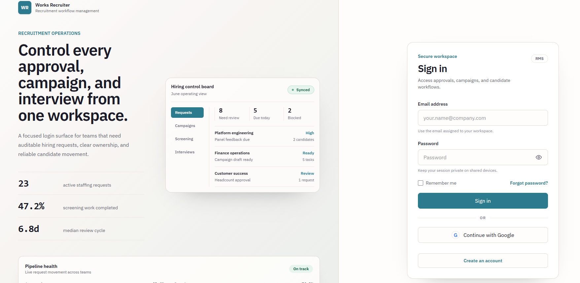
Image 01 - Default Login Page: shows [1] Email, [2] Password, [3] Login, [4] Forgot password, [5] Sign up and [6] general error message.
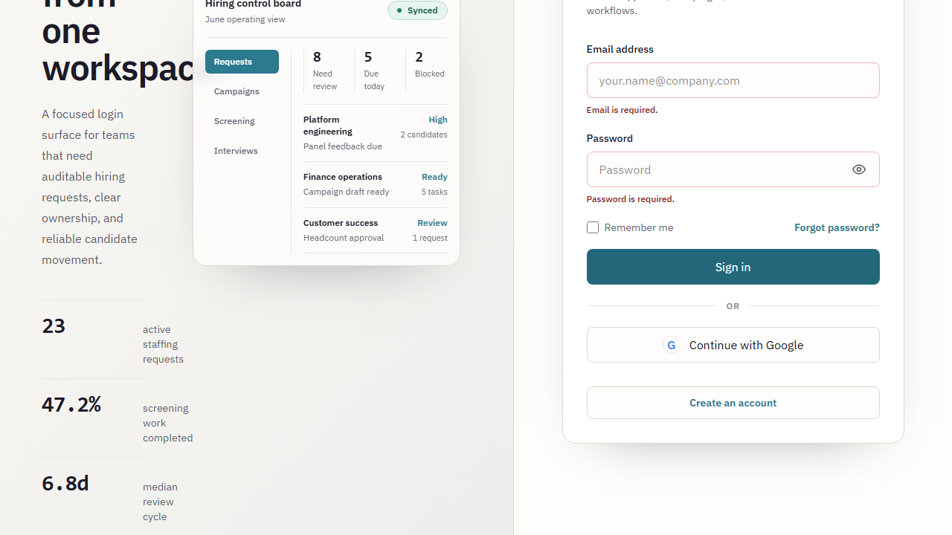
Image 02 - Validate Login: press [3] when [1]/[2] are blank; capture red text for each required field.
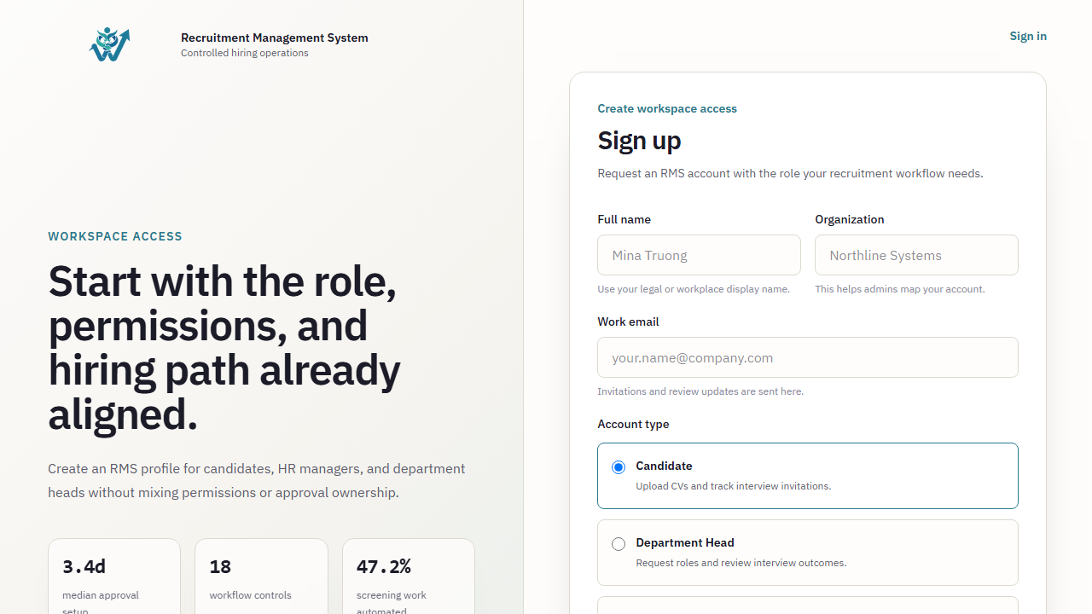
Image 03 - Sign up: shows [7] Full name, [8] Email, [9] Password, [10] Confirm password, [11] Register and terms and conditions.
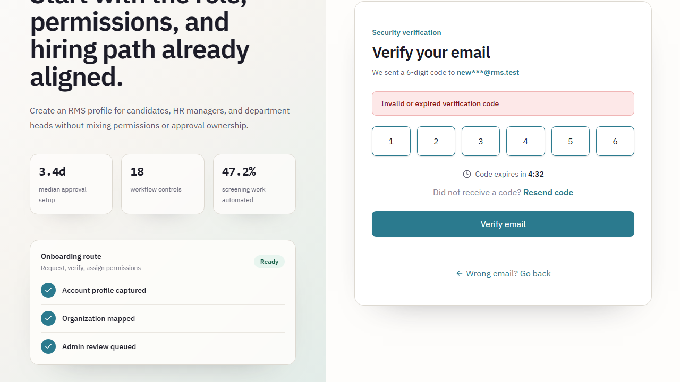
Image 04 - OTP Verification: enter incorrect/expired OTP at [12], take a screenshot of the message and [13] Resend OTP.
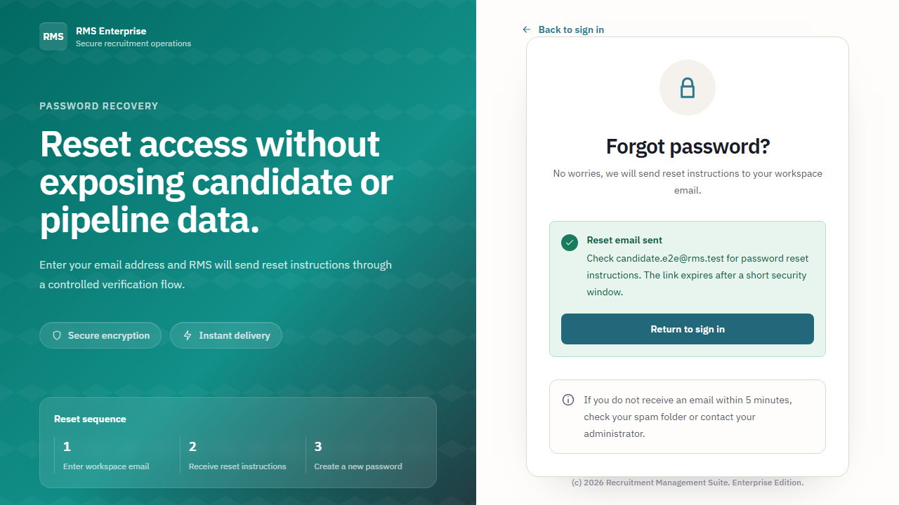
Image 05 - Forgot/Reset Password: enter email at [14], successful submission status (toast) and new password form [15].
Field Name | Field Type | Description | Field Group Name
[1] Email | Text input | Login email; required, email format. | Login form
[2] Password | Password input | Password; required, characters hidden. | Login form
[3] Login | Primary button | Authenticate and create a login session. | Login form
[4] Forgot password | Link | Open the password recovery thread. | Login form
[7]-[11] Registration fields | Inputs/Button | Register and send the OTP for verification. | Registration form
[12]-[15] OTP/Reset controls | OTP input, inputs, buttons | Verify OTP and reset password. | Recovery flow

Database Access
Table | CRUD | Description
User | CRU | Create an account, read the credentials, and update your password/OTP.
AuditLog | C | Record registrations, logins, and password resets.

SQL Commands
-- Authenticate active user
SELECT id, email, display_name, role, is_active FROM users WHERE email = :email AND is_active = true;
-- Create registration
INSERT INTO users (id, email, display_name, password_hash, role, organization_id, is_active, created_at, updated_at) VALUES (:id, :email, :name, :hash, 'CANDIDATE', :organization_id, false, NOW(), NOW());
-- Reset password after verified OTP
UPDATE users SET password_hash = :hash, updated_at = NOW() WHERE id = :user_id;

1.2 Recruitment Request Management

a. Department Head - Create and Track Recruitment Request
The department head creates recruitment requests, saves drafts/submits for approval, tracks the status, and receives feedback from the Admin/HR team.
UI Design
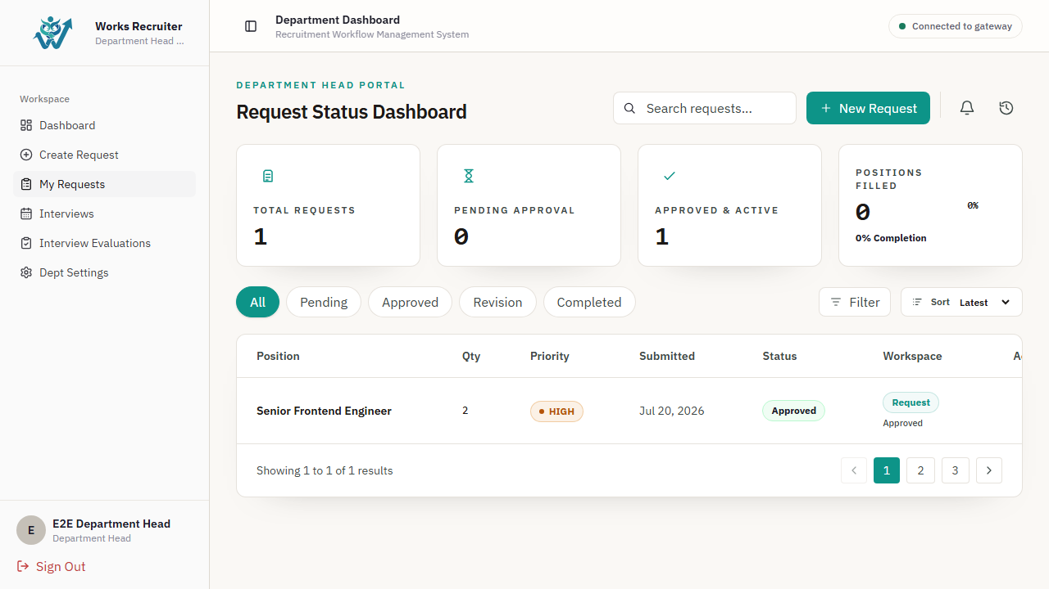
Image 06 - Request list: shows [16] keyword search, [17] status filter, [18] Create request, [19] list table, [20] pagination.
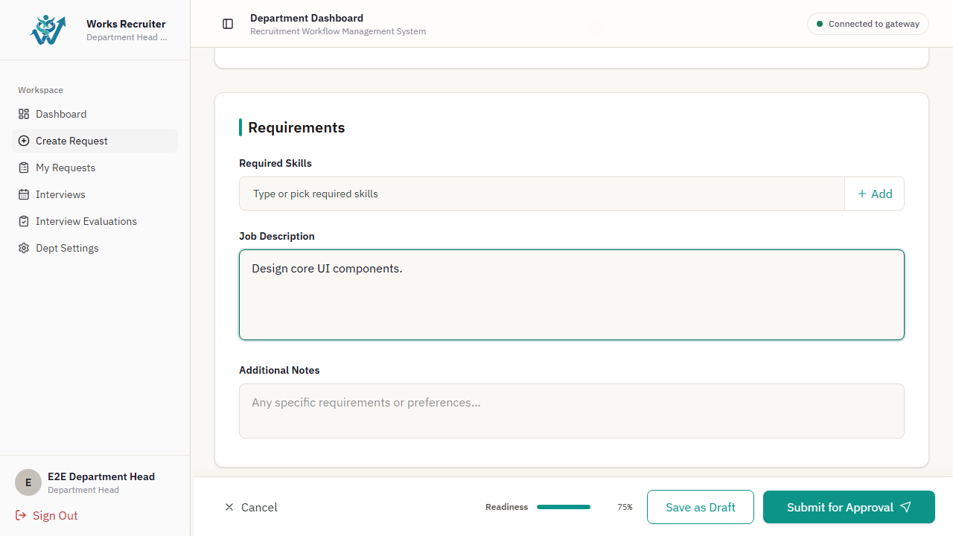
Picture 07 - Create request: shows [21] Position, [22] Department, [23] Quantity, [24] Priority, [25] Job description, [26] Save draft, [27] Submit.
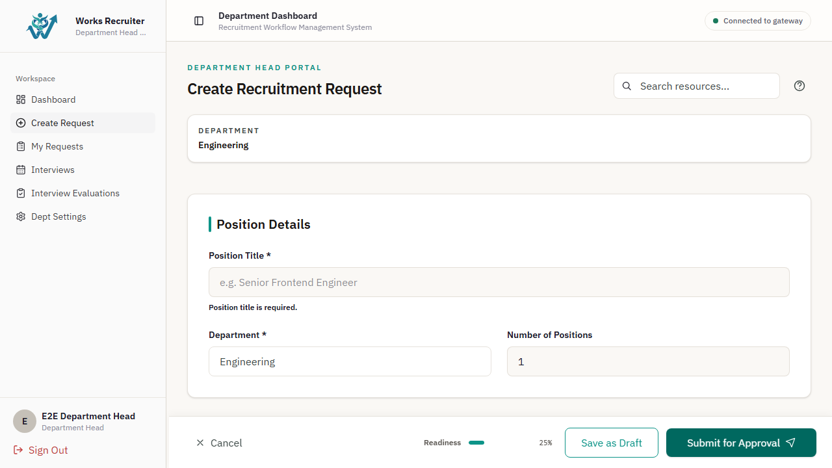
Image 08 - Validate: press [27] when the required field is blank; red error for [21]-[25].
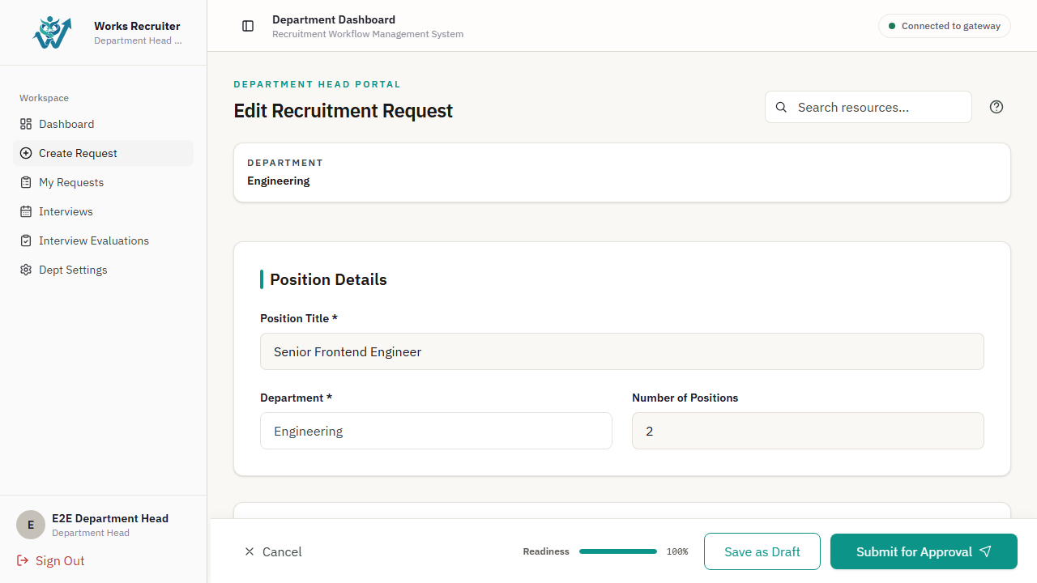
Image 09 - Confirmation/toast: Confirm Submit, then capture successful toast and PENDING_APPROVAL status.
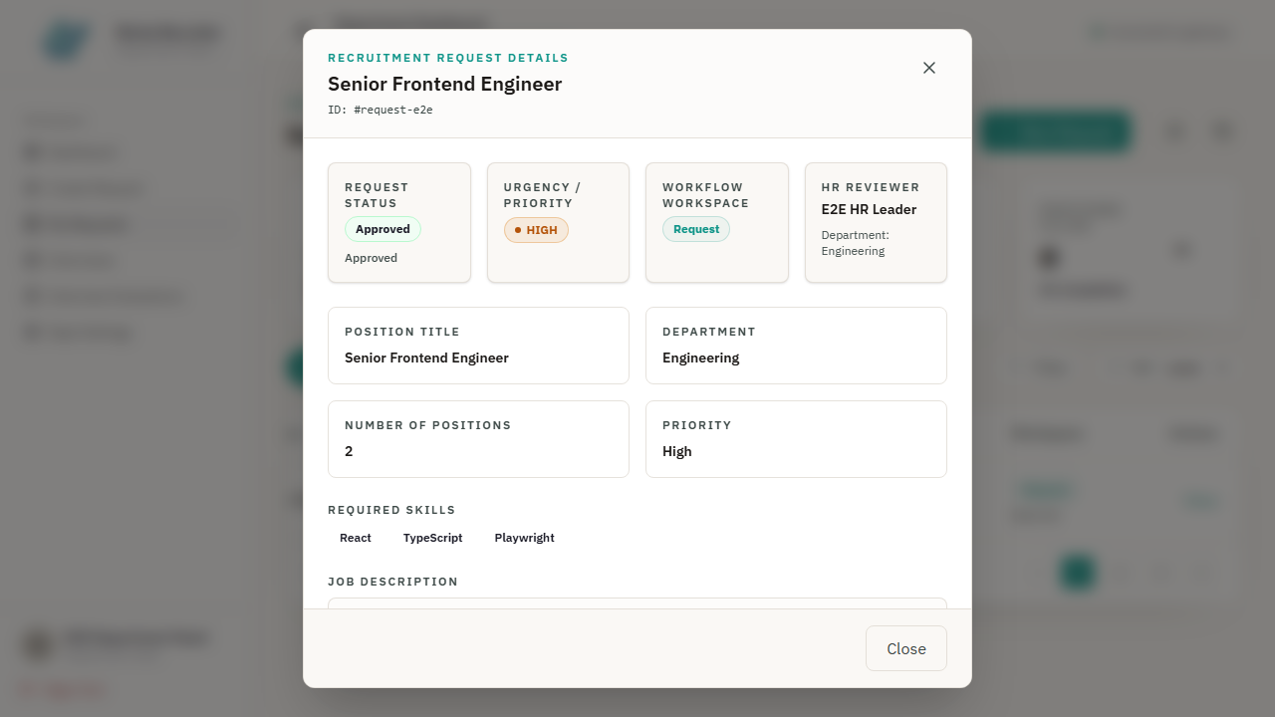
Image 10 - Request detail: timeline [28] Request log and reason for reject/revision [29] if any.
Field Name | Field Type | Description | Field Group Name
[16] Keyword search | Search input | Search by location code/name. | Filter bar
[17] Status | Dropdown | Filter Draft, Pending, Approved, Rejected, Revision requested. | Filter bar
[18] Create request | Button | Open the request creation form. | Toolbar
[19] Request table | Data table | Code, location, department, quantity, priority, status, updated at. | List
[21]-[25] Request fields | Inputs/dropdowns/textarea | Recruitment data required; * fields are mandatory. | Request form
[26]-[29] Actions and log | Buttons/timeline | Save draft, submit for review, processing history. | Form/detail

Database Access
Table | CRUD | Description
RecruitmentRequest | CRU | Create, read lists/details, update drafts/submission status.
RequestLog | CR | Record and display the history of state transitions.
Department | R | Get the department of the person making the request.

SQL Commands
-- Paged request list
SELECT rr.id, rr.position, rr.headcount, rr.urgency, rr.status, rr.updated_at FROM recruitment_requests rr WHERE rr.department_id = :department_id AND (:keyword IS NULL OR rr.position ILIKE '%' || :keyword || '%') AND (:status IS NULL OR rr.status = :status) ORDER BY rr.updated_at DESC LIMIT :page_size OFFSET :offset;
-- Create draft
INSERT INTO recruitment_requests (id, position, department_id, headcount, urgency, job_description, skill_requirements, justification, status, created_by_id, created_at, updated_at) VALUES (:id, :position, :department_id, :headcount, :urgency, :job_description, :skill_requirements::jsonb, :justification, 'DRAFT', :user_id, NOW(), NOW());
-- Submit request
UPDATE recruitment_requests SET status = 'PENDING_APPROVAL', updated_at = NOW() WHERE id = :id AND status = 'DRAFT';

1.3 HR Recruitment Operations

a. Campaign, Job Posting, Candidate CV and AI Search
HR receives approved requests, implements campaigns/posts, manages the talent pool, processes CVs, and searches for candidates using AI.
UI Design
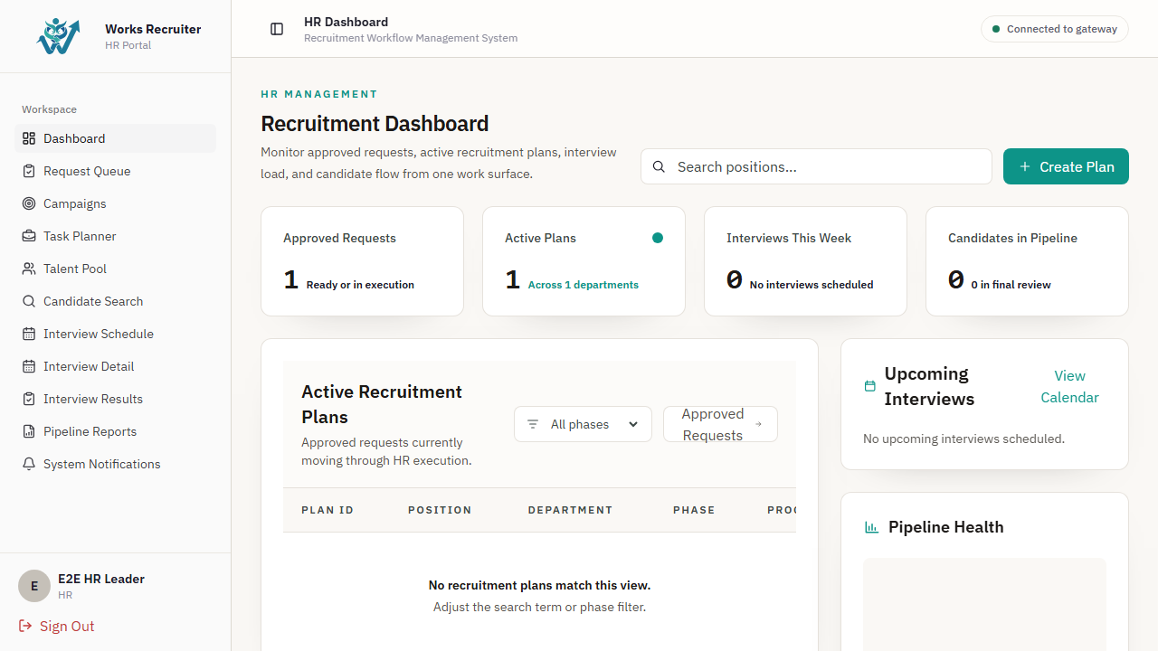
Image 11 - HR Dashboard: KPI [30], pipeline chart [31], tasks to be handled [32].
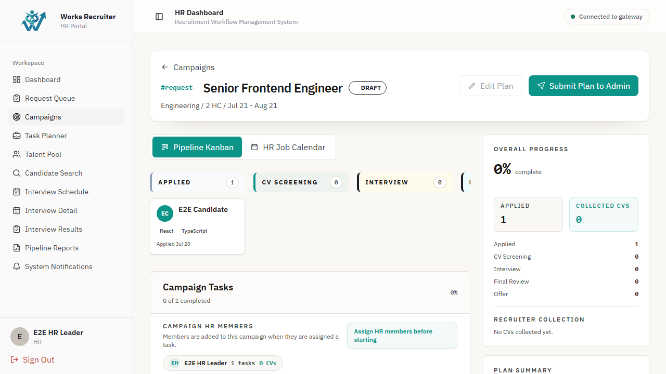
Picture 12 - Campaign list/detail: [33] filters, [34] Create campaign, [35] campaign cards/table, [36] candidate pipeline.
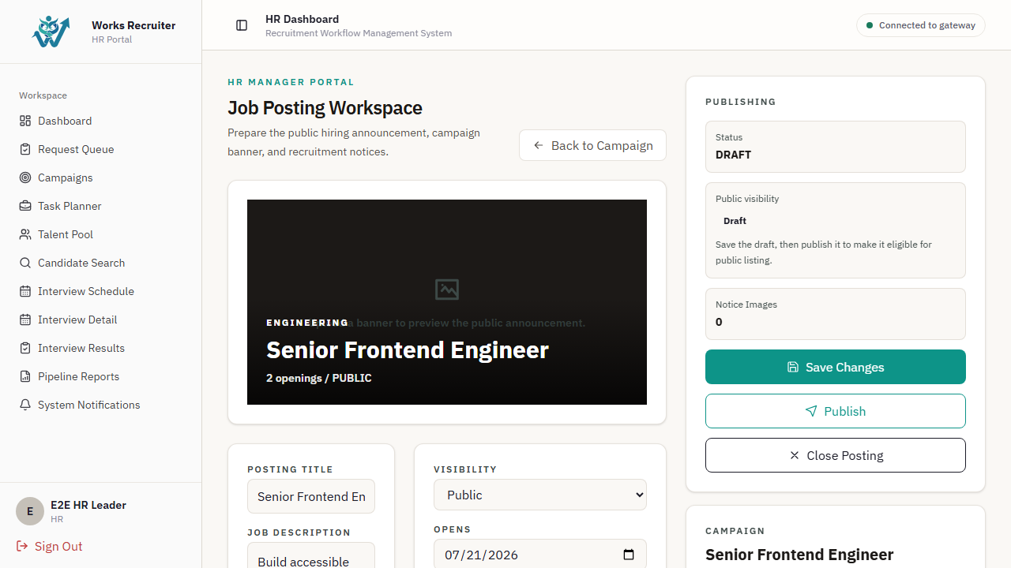
Image 13 - Job posting workspace: [37] job posting information, [38] Publish/Unpublish, [39] status preview.
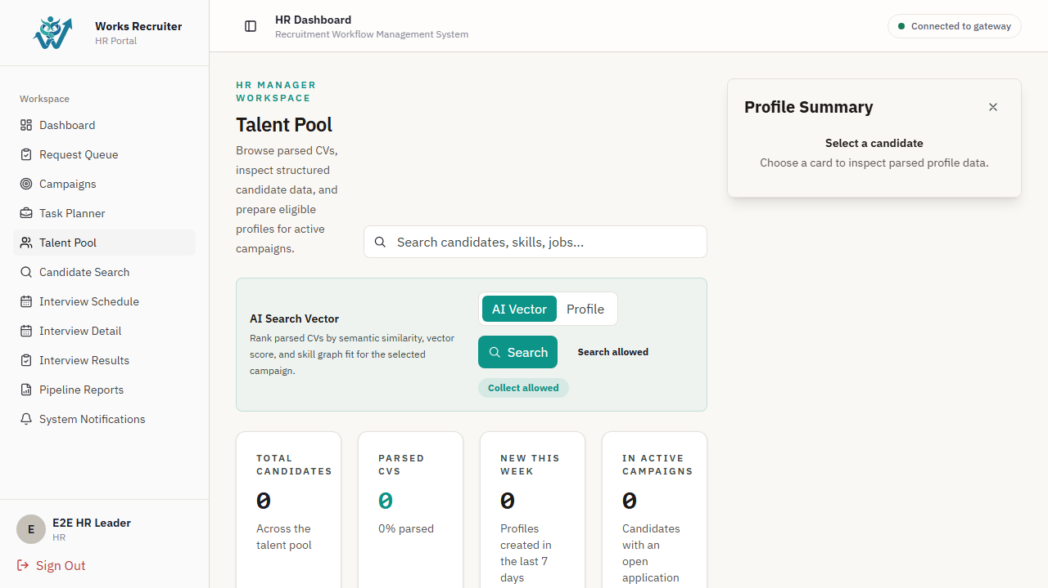
Photo 14 - Talent pool/CV: [40] candidate search, [41] upload/replace CV, [42] parse status, [43] candidate profile drawer.
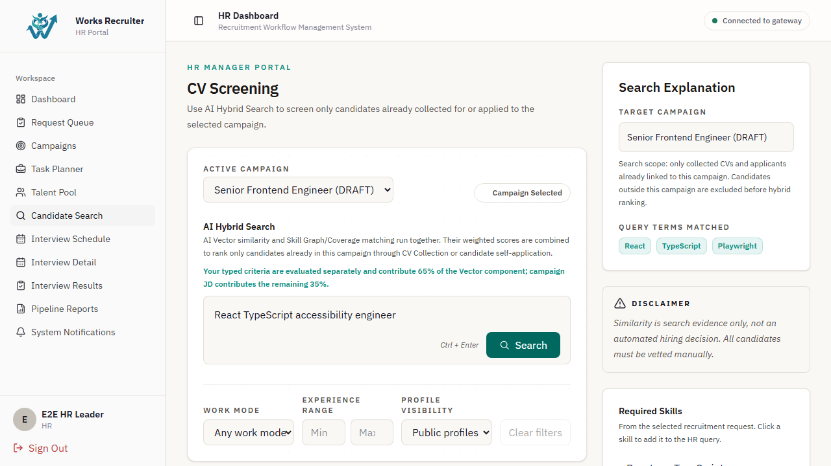
Image 15 - AI search: enter criteria [44], filter [45], results/ranking [46], shortlist [47]; capture empty state when no results.
Field Name | Field Type | Description | Field Group Name
[30]-[32] HR dashboard widgets | Cards/charts/list | Overview of requirements, plan, interviews, and pipeline. | Dashboard
[33]-[36] Campaign controls | Filters/button/table/pipeline | Create and track recruitment campaigns. | Campaign
[37]-[39] Job posting controls | Form/buttons/preview | Draft, publish, and stop posting.. | Job posting
[40]-[43] Candidate CV controls | Search/upload/status/drawer | Manage profiles, resumes, and extracted results. | Talent pool
[44]-[47] AI search controls | Text input/dropdowns/list/button | Find semantics, filter, and shortlist candidates. | AI search

Database Access
Table | CRUD | Description
RecruitmentRequest | RU | Read the approved request and update the processing stage.
JobPosting | CRU | Create, publish, and update posts.
CandidateProfile, CandidateCV | CRU | Read/create/update candidate and CV information.
CvEmbedding, TalentSearchRun, TalentSearchFeedback | CR | Save vector data, search history, and AI search responses.

SQL Commands
-- Candidate search with paging
SELECT cp.id, cp.full_name, cp.email, ccv.id AS cv_id FROM candidate_profiles cp LEFT JOIN candidate_cvs ccv ON ccv.candidate_id = cp.id WHERE (:keyword IS NULL OR cp.full_name ILIKE '%' || :keyword || '%') ORDER BY cp.updated_at DESC LIMIT :page_size OFFSET :offset;
-- Publish job posting
UPDATE job_postings SET status = 'PUBLISHED', start_date = NOW(), updated_at = NOW() WHERE id = :id AND status IN ('DRAFT', 'CLOSED');
-- Store CV metadata
INSERT INTO candidate_cvs (id, candidate_id, file_name, file_type, file_path, raw_text, processing_status, created_at, updated_at) VALUES (:id, :candidate_id, :file_name, :file_type, :file_path, :raw_text, 'PROCESSING', NOW(), NOW());

1.4 Interview and Hiring Decision

a. Schedule Interview, Record Result and Manage Offer
HR coordinates interview schedules, relevant parties confirm/evaluate; HR makes hiring decisions and manages candidate offer letters.
UI Design
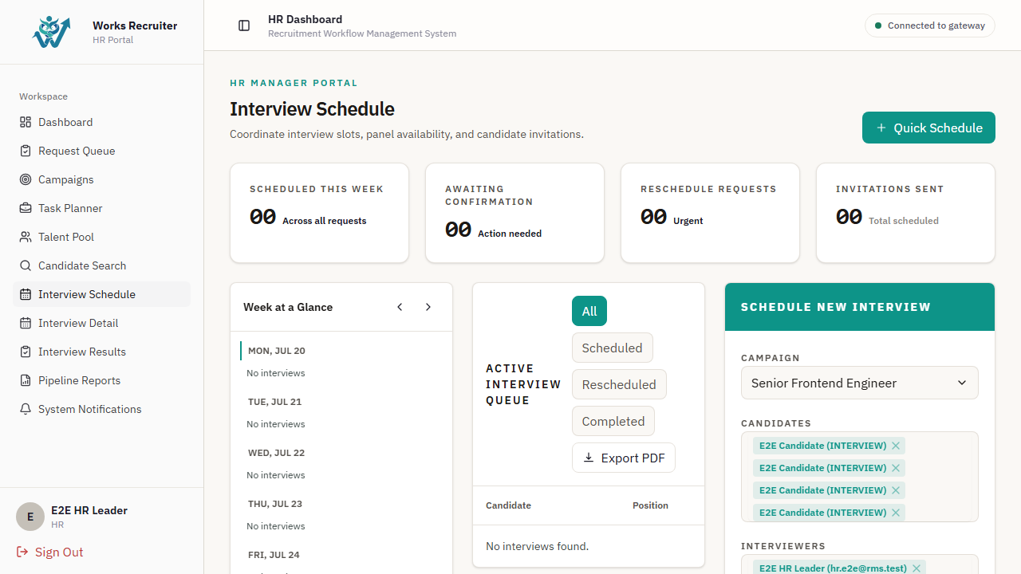
Photo 16 - Interview calendar/list: [48] date range, [49] status filter, [50] Interview schedule, [51] calendar/table.
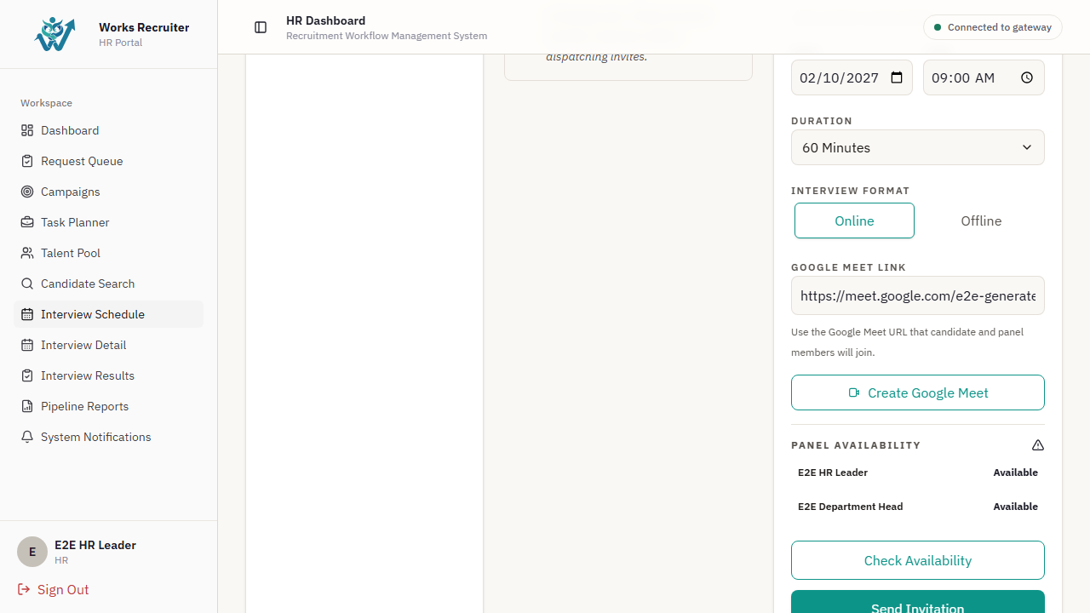
Photo 17 - Schedule modal: [52] candidates, [53] interviewers, [54] date/time, [55] meeting location/link, [56] Save; Capture conflict validation.
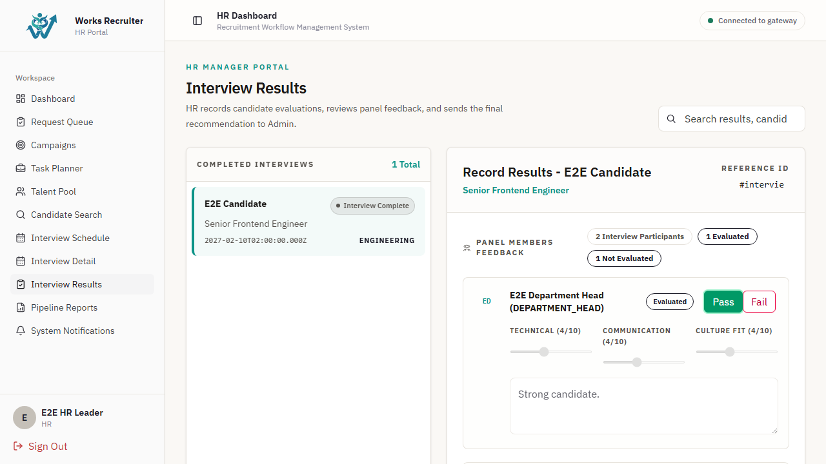
Photo 18 - Interview detail/result: [57] attendance, [58] score/feedback, [59] Submit result; photo of completed status.
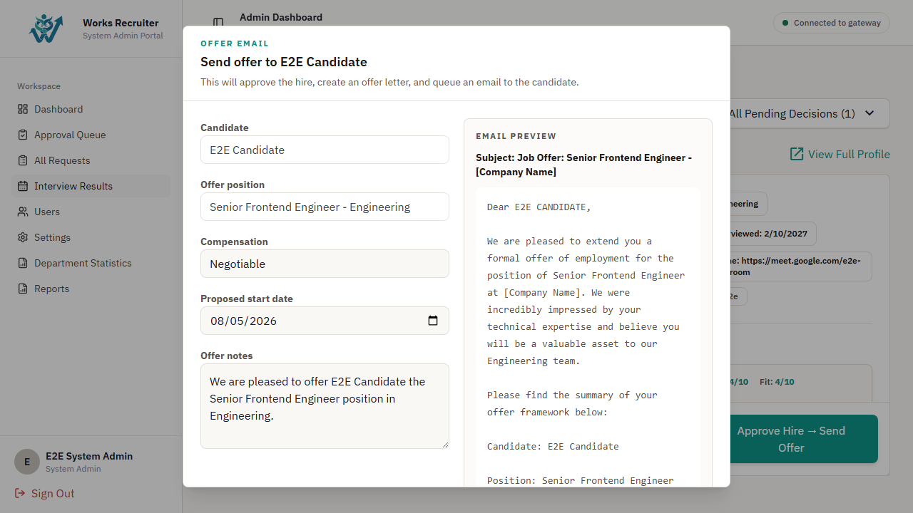
Picture 19 - Offer management: [60] decision, [61] offer form, [62] Send offer, [63] candidate accept/reject confirmation.
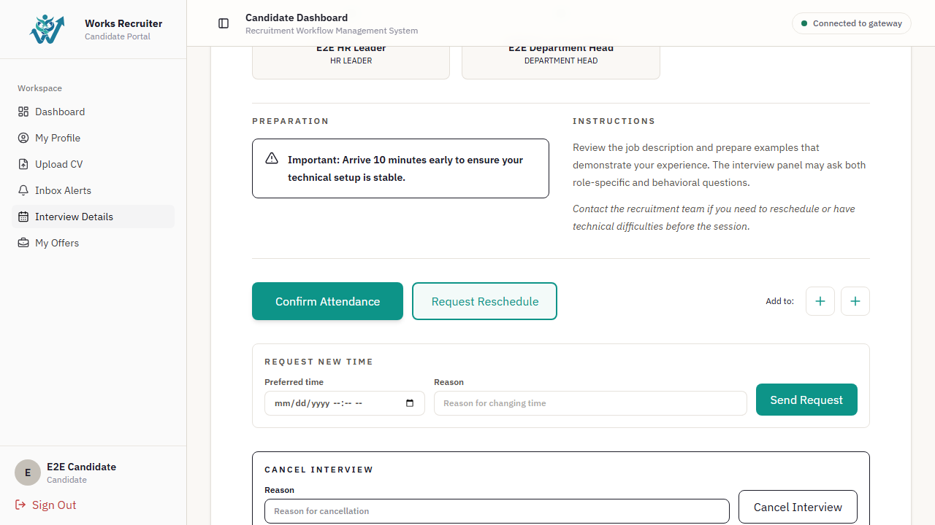
Image 20 - Cancellation/reschedule: confirmation modal [64], reason [65] and toast notification.
Field Name | Field Type | Description | Field Group Name
[48]-[51] Interview calendar | Filters/button/calendar/table | Find and display interview schedules. | Schedule list
[52]-[56] Schedule fields | Selectors/datetime/button | Create a schedule; check for candidate/interviewer scheduling conflicts. | Schedule modal
[57]-[59] Result controls | Checkbox/input/textarea/button | Record attendance, scores, and comments. | Interview detail
[60]-[63] Offer controls | Dropdown/form/buttons | Making hiring decisions and sending/receiving offers. | Offer management
[64]-[65] Cancel/reschedule | Modal/textarea | Confirm and state the reason for the schedule change. | Modal

Database Access
Table | CRUD | Description
InterviewSchedule | CRU | Create, read, reschedule/cancel interviews.
InterviewResult | CRU | Save the evaluation and interview results.
OfferLetter | CRU | Create/send/update offer responses.
Notification, EmailLog | C | Create notifications and email logs for schedule/offer changes.

SQL Commands
-- Detect schedule conflict
SELECT id FROM interview_schedules WHERE :interviewer_id = ANY(interviewers) AND status = 'SCHEDULED' AND scheduled_at < :end_at AND (scheduled_at + interval '1 minute' * duration) > :start_at;
-- Create interview schedule
INSERT INTO interview_schedules (id, candidate_id, request_id, scheduled_at, duration, location, status, interviewers, created_at, updated_at) VALUES (:id, :candidate_id, :request_id, :scheduled_at, :duration, :location, 'SCHEDULED', :interviewers, NOW(), NOW());
-- Save interview result
INSERT INTO interview_results (id, interview_id, result, notes, evaluator_id, technical, communication, culture, created_at, updated_at) VALUES (:id, :interview_id, :result, :notes, :evaluator_id, :technical, :communication, :culture, NOW(), NOW());
-- Send offer
UPDATE offer_letters SET status = 'SENT', sent_at = NOW(), updated_at = NOW() WHERE id = :id;

1.5 Administration, Reporting and Candidate Self-service

a. Admin Control, Reports, Candidate Profile, CV and Offer
Admin manages users, approves applications, and reports; candidates update their profiles, upload CVs, track interviews/offers, and receive notifications.
UI Design
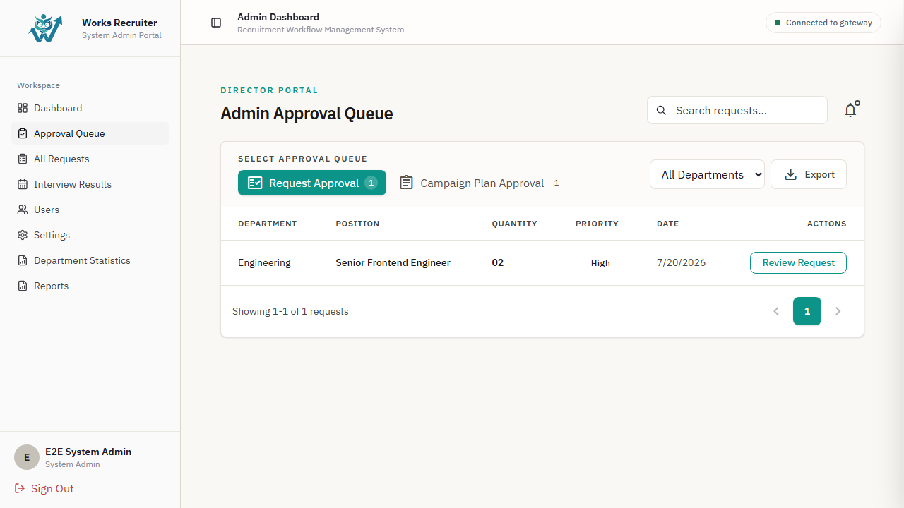
Picture 21 - Admin approval queue: [66] status filter, [67] request rows, [68] Approve, [69] Reject/Revision modal, [70] reason.
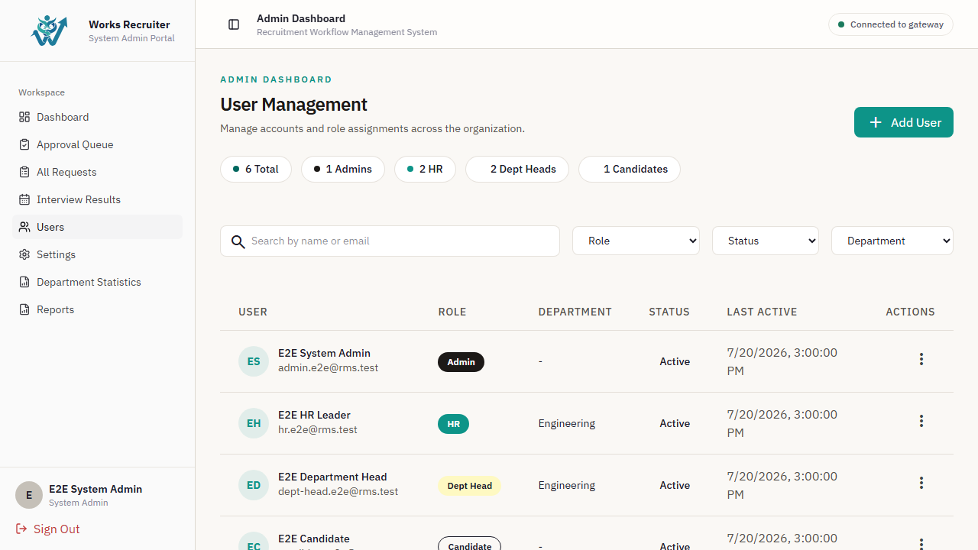
Picture 22 - User management: [71] search/filter, [72] user table, [73] create/edit user, [74] role/status dropdown, [75] confirmation toast.
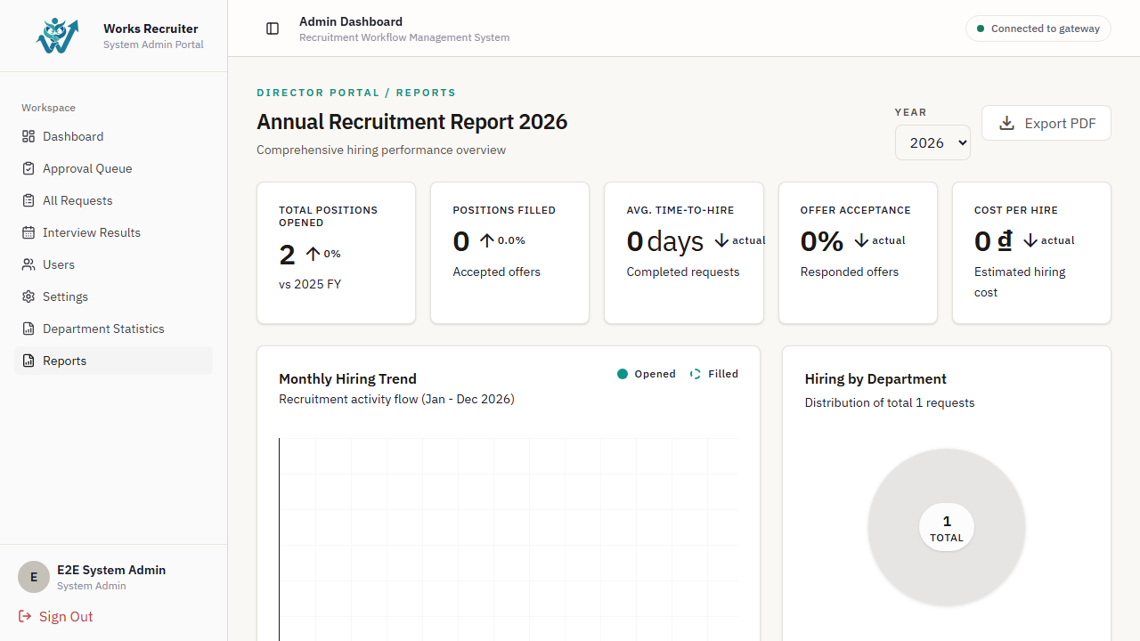
Picture 23 - Reports: [76] reporting period, [77] department filter, [78] KPI cards, [79] charts, [80] export.
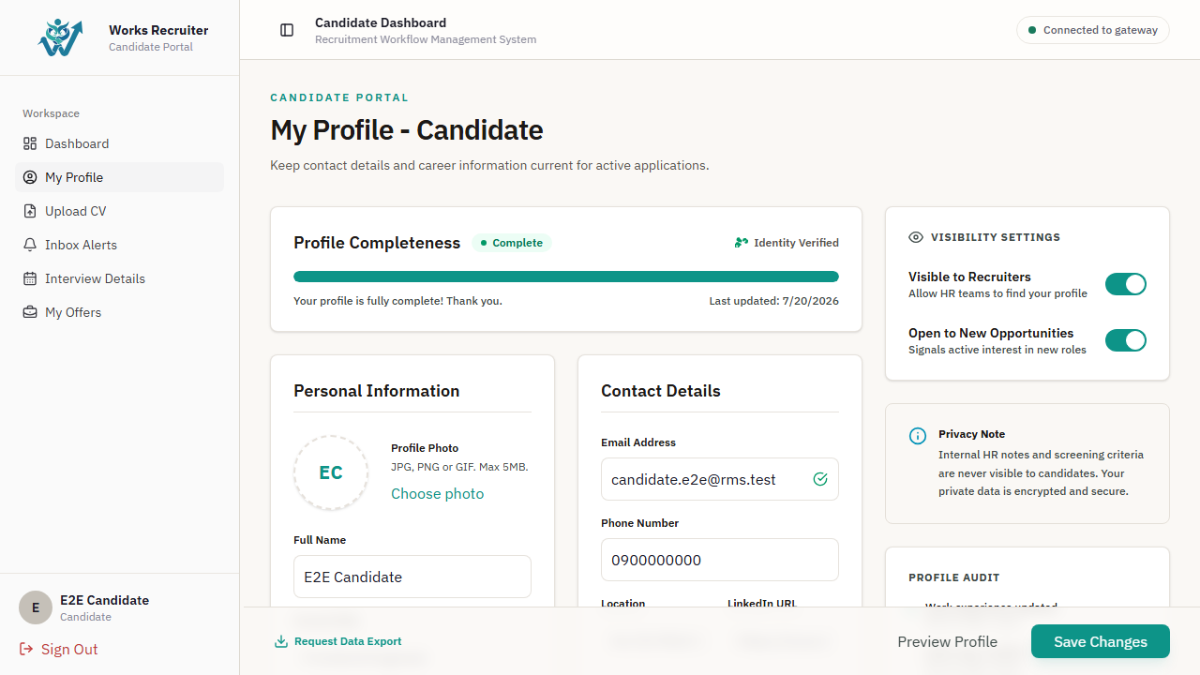
Photo 24 - Candidate profile/CV: [81] profile fields, [82] Save profile, [83] Upload CV/drop zone, [84] extraction result and toast.
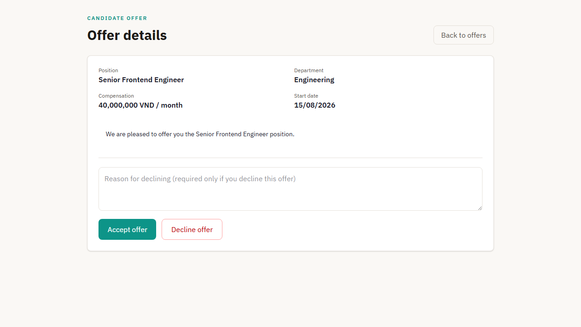
Photo 25 - Candidate interviews/offers: [85] interview detail, [86] Confirm/Reschedule, [87] offer detail, [88] Accept/Reject, [89] notification list.
Field Name | Field Type | Description | Field Group Name
[66]-[70] Approval controls | Filter/table/buttons/modal | Approve, reject, or request revisions to the request. | Admin approval
[71]-[75] User controls | Search/table/form/dropdown/toast | Manage accounts, roles, and statuses. | Admin users
[76]-[80] Report controls | Date/filter/cards/charts/button | Track KPIs and generate reports. | Reports
[81]-[84] Candidate profile/CV | Inputs/button/upload/status | Update your profile and upload/parse your CV. | Candidate portal
[85]-[89] Candidate lifecycle | Detail/actions/list | Confirm the schedule, respond to the offer, and read the announcement. | Candidate portal

Database Access
Table | CRUD | Description
ApprovalRecord | CR | Record the decision to approve/reject/request revisions.
User | CRU | Manage users, roles, and status.
RecruitmentRequest, JobPosting, CandidateProfile, InterviewSchedule, OfferLetter | R | Compile dashboard/report data.
CandidateProfile, CandidateCV, Notification | RU/C | Candidates update their profile/CV and receive notifications.

SQL Commands
-- Approve request transaction
UPDATE recruitment_requests SET status = 'APPROVED', approved_by_id = :admin_id, updated_at = NOW() WHERE id = :request_id AND status = 'PENDING_APPROVAL';
INSERT INTO approval_records (id, request_id, approver_id, decision, comments, decided_at) VALUES (:id, :request_id, :admin_id, 'APPROVED', :comments, NOW());
-- Admin report aggregation
SELECT d.name, COUNT(DISTINCT rr.id) AS request_count, COUNT(DISTINCT cp.id) AS candidate_count FROM departments d LEFT JOIN recruitment_requests rr ON rr.department_id = d.id LEFT JOIN candidate_profiles cp ON cp.user_id IN (SELECT id FROM users WHERE department_id = d.id) WHERE (:department_id IS NULL OR d.id = :department_id) GROUP BY d.name ORDER BY request_count DESC;
-- Candidate update profile
UPDATE candidate_profiles SET full_name = :full_name, phone = :phone, updated_at = NOW() WHERE user_id = :user_id;

IV. Appendix

1. Assumptions & Dependencies
AS-1: The Monorepo application runs on Node.js v18/v20 and PostgreSQL (version 14 or above) with pgvector extension enabled.
AS-2: Candidates will upload CVs in standard formats: PDF, DOCX, or DOC, and the uploaded files must contain extractable text.
AS-3: Recruiter interactions (views, shortlists, schedules, hires, rejects) occur inside campaigns so that semantic feedback propagation can be contextualized.
DE-1: The local AI Worker relies on the pre-compiled ONNX format of the multilingual-e5-small model (rms_custom) loaded locally from the @xenova/transformers library.
DE-2: Supabase Auth and Google OAuth are required for federated authentication, and the browser must handle Google login sessions.
DE-3: The Google Calendar API and Google Meet integration require valid developer credentials and consent screen approval to schedule virtual interviews.

2. Limitations & Exclusions
LI-1: The local embedding worker executes on standard CPU, which may limit concurrency if hundreds of CVs are uploaded simultaneously. A queue system (BullMQ/Redis) is used to throttle processing to one CV at a time.
LI-2: The skill graph is stored in-memory on the Gateway/Recruiting microservice. In a multi-instance production deploy, a centralized graph sync or redis caching mechanism is required to share graph updates.
EX-1: The system does not support automatic candidate background checks or direct integration with government employment databases.
EX-2: Direct payroll processing or contract e-signatures are excluded from this release; the system only extends offers and records acceptances/declines.

3. Business Rules
Below are the core business rules enforced across the Recruitment Management System (RMS):

ID | Category | Rule Definition
BR-01 | Authorization | Only active Admin users can configure organization department details and change global user roles.
BR-02 | Workflow Constraints | A recruitment request must be created as DRAFT by a Department Head, forwarded by HR after review, and approved by the Admin before any campaign (OverallPlan) can be created.
BR-03 | State Integrity | An interview schedule cannot be created unless the campaign status is ACTIVE, and the candidate profile has an uploaded and parsed CV.
BR-04 | State Integrity | An offer letter cannot be sent to a candidate unless their interview schedule status is COMPLETED and they have received a HIRE recommendation.
BR-05 | Computations | The candidate overall matching score is calculated as 0.4 * Vector Similarity + 0.35 * Skill Graph Proximity + 0.25 * Required Skill Coverage, multiplied by the P_Vector penalty and adjusted by R_Rerank and Score_Feedback.
BR-06 | Feedback Loop | HR actions viewed, shortlisted, scheduled, hired (+), and rejected (-) adjust the candidate's score. Semantic propagation propagates feedback to similar candidates (similarity >= 0.82) with negative feedback rate lambda = 0.05 and positive lambda = 0.2.
BR-07 | Data Isolation | All database queries must enforce tenant isolation by filtering by organizationId to prevent unauthorized access between departments or organizations.

